Mrs Corpas' complete IGCSE case studies

Table of contents

Topic |  | Case Study Required | Sancton Wood  Case Study | Page number
Population1.1 Population dynamics | 1.1 | A country which is overpopulated | Bangladesh | 2
Population1.1 Population dynamics | 1.1 | A country which is under-populated | Australia | 5
Population1.1 Population dynamics | 1.1 | A country with a high rate of natural population growth | Bangladesh | 4
Population1.1 Population dynamics | 1.1 | A country with a low rate of population growth (or population decline) | Japan | 6/7
Population  1.2 Migration | 1.2 | An international migration | Poland to UK | 8
Population  1.3 Population structure | 1.3 | A country with a high dependent population | Japan | 6/7
Population  1.4 Population density and distribution | 1.4 | A densely populated country or area (at any scale from local to regional) | South East England | 10
Population  1.4 Population density and distribution | 1.4 | A sparsely populated country or area (at any scale from local to regional) | Scottish Highlands | 11
Settlement  1.5 Settlements and service provision | 1.5 | Settlement and service provision in an area | South Cambridgeshire | 12
Settlement  1.6 Urban settlements | 1.6 | An urban area or areas | London/ Cambridge
Settlement  1.7 Urbanisation | 1.7 | A rapidly growing urban area in a developing country and migration to it | Mumbai, India
2.1 Earthquakes and volcanoes | 2.1 | An earthquake | Haiti 2010
2.1 Earthquakes and volcanoes | 2.1 | A volcano | Mount Soufriere, Montserrat 1997
2.2 Rivers | 2.2 | The opportunities presented by a river or rivers, the associated hazards and their management | Mississippi River, USA
2.3 Coasts | 2.3 | The opportunities presented by an area or areas of coastline, the associated hazards and their management | North Norfolk coast & Happisburgh (erosion)
2.4 Weather  2.5 Climate and natural vegetation | 2.5 | An area of tropical rainforest | CLIMATE &  Deforestation of TRF in Borneo
2.4 Weather  2.5 Climate and natural vegetation | 2.5 | An area of hot desert | CLIMATE of Namibia  Namibia / Sahara & land use
3.1 Development | 3.1 | A transnational corporation and its global links | Nike
3.2 Food production | 3.2 | A farm or agricultural system | Rockells Farm, Elmdon Essex
3.2 Food production | 3.2 | A country or region suffering from food shortages | Swaziland
3.3 Industry | 3.3 | An industrial zone or factory | Cambridge Science Park
3.4 Tourism | 3.4 | An area where tourism is important | Lanzarote
3.5 Energy | 3.5 | Energy supply in a country or area | Iceland
3.6 Water | 3.6 | Water supply in a country or area | Water supply in Northern India
3.7 Environmental risks of economic development | 3.7 | An area where economic development is taking place causing the environment to be at risk | Palm Oil Production in Borneo

POPULATION TOPIC

Population 1.1 Population dynamics

- A country which is overpopulated
- A country with a high rate of natural population growth

Case study of Overpopulation/ high rate of natural population growth: Bangladesh
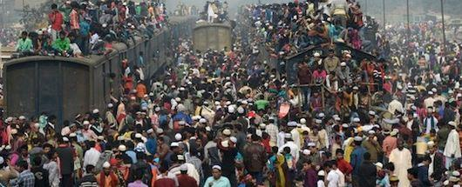

OVERPOPULATION: (FOR RAPID GROWTH SEE END)
What is the definition of overpopulation and why is Bangladesh considered to be overpopulated?
1. Overpopulation occurs when there are too many people in an area relative to the amount of resources, leading to a lowering of standards of living.
2. Bangladesh has a population of 147 million people (seventh largest in the world) and the area of Bangladesh is roughly 3., but with an estimated 160 million citizens over an area of around 144,000 km².
3. The population density is therefore 1,252 people per square kilometer which makes it Bangladesh is the 12th most densely settled nation on earth (2016)
4. Bangladesh also has a high population growth rate of just over 2% per year.
5. Bangladesh is a poor country and lacks sufficient resources to meet the needs of its population, which leads to a lowering of standards of living with many people living in poverty. The lack of capital has meant that the country has struggled to fully develop its economy and raise the standards of living of its people. GDP per capita is 1,358.78 USD (2016)
6. Bangladesh is a heavily agriculture based economy (47% primary in 2010)
7. High density of population means that agricultural land is virtually saturated, with very limited capacity to expand food production.
8. 31.5% of Bangladeshis live below the national poverty line.

What are the problems of Overpopulation in rural areas of Bangladesh?
1. Many people live on the fertile floodplains of the Ganges and the Brahmaputra River, farming rice and other agricultural products.
2. Due to these areas becoming so densely populated, the land is heavily farmed, leading to Over cultivation (Overuse of the land which results in taking too many nutrients from the soil).
3. The farmers are poor and therefore cannot afford to replace the nutrients in the soil, so the soil becomes infertile, which leads to a lowering of crop yields. This can cause an insufficient supply of food and result in some people becoming Malnourished ( 41% in 2011)
4. Bangladesh suffers from annual floods during the Monsoon season. Tropical Cyclones are also funneled up the Bay of Bengal where dense populations live on the fertile floodplains of the Ganges Delta. As a result of being poor, and having insufficient resources to protect themselves from these Climatic Hazards, this often results in a high death rate.
5.In 2007 more than half of Bangladesh was seriously affected by deadly monsoon flooding, over 1000 dead, mostly children.
6.2017 summer floods (during rice growing season) 142 people dead and impacted over 8.5 million. 700,000 homes have been partially or totally destroyed and up to a third of the land, much of it farmland, has been submerged.

What are the problems of Overpopulation in Bangladesh’s cities?
1. Dhaka is the capital city of Bangladesh, and many people have migrated to Dhaka from the rural areas. This increases the population density in Dhaka and puts pressure on resources such as housing, health care, water and sanitation, education etc.
2. Dhaka has a population of 14.4 million and a population density of 19,447 people per square kilometer (compared to 1,510 in London)
4. Many people cannot afford to live in permanent accommodation and will be forced to live in Bustees (name for Shanty towns in India and Bangladesh) located on the edge of the Dhaka. These residences are semi-permanent, sub-standard, overcrowded and lack amenities such as electricity, sewage disposal, and clean water supplies, which contribute towards the spread of diseases and an increase in the death rate.
4. Slum issues : slum density is 891 people per acre compared to 121 people per acre in the city as a whole
43% of the city's population live in these slums (2010)
Only 57.6% of households in slums have access to cooking gas (2008)

Only 35.6% have access to latrines
literacy rates in slums: 14.66% where the male literacy rate was 17.88 and female literacy rate was 11.32% respectively
5 Too many people in the cities cause a stress on health care and medical facilities such as hospitals and medication, which again contributes towards a higher death rate. DR = 5.61per 1000/year
6. number of doctors per 1000 is 0.36 in 2013 compared with with 3.2 in France.
7. More people mean more traffic, which causes congestion problems and the release of Nitrous Oxide from exhaust fumes causes air pollution. With limited funds the government cannot afford to develop the transport system.
8. Many people will not be able to find a job which leads to high unemployment rates, or people working in low paid informal sector employment. In addition to this, poor access to education in both rural and urban areas results in many people being unqualified and therefore they struggle to get a well paid job and live in poverty.
What are some the solutions to these problems?
1. Provide more knowledge and availability to contraceptives such as condoms and the pill.
Build more family planning and educate the people regarding the dangers of having too many children.
2. Raise literacy rates and enable better access to education, which can contribute towards improving the status of females and contribute to a lowering of the birth rate.
3. Develop industry and increase exports, which can lead to economic growth and increased wealth in the country. Money can then be spent on improving infrastructure such as sewage systems, clean piped water supply, and hospitals etc which will lower the death rate, increase life expectancy and improve the standards of living. Increased wealth can also contribute to improvements in technology, such as the use of more productive agricultural techniques such as the use of agrochemicals and HYVs, which will improve people’s diet, lower the death rate and increase life expectancy.
4. Build more flood defence schemes and shelters to protect people from Climatic Hazards such as floods and Cyclones.

HIGH RATE OF NATURAL POPULATION GROWTH

The 2011 census pegs the population of Bangladesh at 150.6 million, reflecting an increase of more than 20 percent over the 2001 census population levels
1.6% growth rate (2015 est.)

Birth rate | 21.14 births/1,000 population (2015 est.)
Death rate | 5.61 deaths/1,000 population (2015 est.)

Why is the population grow rate high? Causes of high rate of natural population growth
1. 56% of the women in Bangladesh are in the reproductive age group of 15–49 years.
2. Another 31% of the population is below the age of 15 years and will soon be entering the reproductive life span and contributing to the increasing numbers.
3. FERTILITY RATE: From extremely high levels of 6.3 in 1975, to 3.3 in the year 2000, the TFR now stands at 2.3 according to the Bangladesh Demographic and Health Survey 2011, which is still some distance away from replacement fertility levels (2.1)
4. There is a general lack of availability and knowledge regarding contraceptives which leads to a high birth rate. Only 61.2% contraceptive use in 2011. There exists an urban-rural divide in the use of contraception with 52% of the urban women using a modern method of contraception compared to only 46% of the rural women.
5.17% of all married women have an unmet need for family planning due to lack of access
6.: Bangladesh has a high adolescent fertility rate, one of the highest amongst the SEAR nations and a lower uptake of contraceptives in this age group
7. Large proportion of population work as subsistence farmers and children are regarded as an economic asset and therefore people have lots of children to help them work on the farms.
4. There is no state pension system in Bangladesh, so people also have lots of children with the hope that their children will take care of them when they are too old to work and provide for themselves.
5. Bangladesh is a poor country (GDP per capita is approximately $240.00), which lacks suitable medical facilities and vaccinations. IMR (Infant Mortality Rate) is therefore high and so people have lots of children to replace those that die at a young age.
6. Females are not fully emancipated which is another contributory factor to the country having a high birth rate.

http://www.thedailystar.net/news-detail-93293
http://www.searo.who.int/entity/child_adolescent/topics/child_health/fp-ban.pdf?ua=1
https://economicsbd.wordpress.com/2011/03/06/a-brief-history-of-economics/
https://edition.cnn.com/2017/09/01/asia/bangladesh-south-asia-floods/index.html

Population 1.1 Population dynamics

1.1 A country which is under-populated: Australia

Case study: Underpopulation in Australia

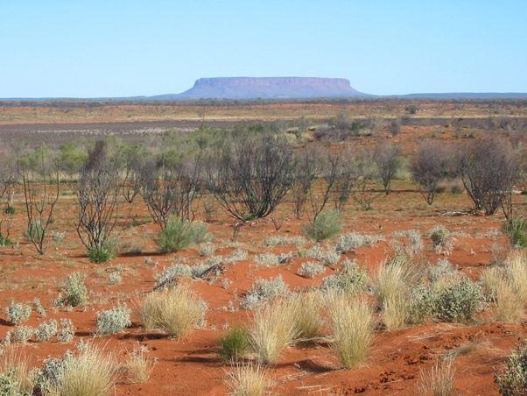

What is Underpopulation?
If the number of people living in an area is less than needed to make full use of the resources available then the area can be described as underpopulated.

Australia has many resources but it is not using them fully. The country could support a higher population, which means that it is underpopulated.

Area and facts:
- Australia has a population of 22.5 million and is a similar size to the USA. However the USA has 300 million people living in it.
- Population is 22.5 million with a population density of 2.9 per square kilometre, the lowest in the world
- Many areas of Australia are empty and it could support a higher population. Only 10% of the land is inhabited
- Successive governments have tried to increase its population, to develop the country economically and to protect it from foreign influence.
- Natural population growth rate is 0.6%
- Most live on coast as interior is desert
- There is a huge potential for solar and wind power

What problems has underpopulation caused in Australia?

• Shortage of workers which has led to lower optimum productivity. Boston Consulting Group has released a report predicting a shortfall of 2.3 million workers by 2030.
to develop the country economically, Australia started to attract migrants from other countries which raised the Population to 23 million from 3.7 million in 1901.

27% net migration 2016-2017
• Conflicts caused in major cities such as Sydney by need to attract foreign workers.
• Not possible to exploit all resources and large areas of outback undeveloped/underutilised. Northern territory is rich with energy, agriculture, business and other industries, and has vibrant and growing communities but remains under-utilised relative to the rest of Australia, despite its natural, geographic and strategic assets
• Less people paying tax. 43% of the labour force will be due to retire in next 20 years. Taxes will have to be raised to fund retirement. Australia's tax take from individuals and businesses is one of the highest in the developed world, high taxes are levied on the lower and middle income earners and higher income earners are thinking of overseas relocation
• Schools and hospitals may close because there are not enough people to support them.
• Public transport links might close because of less customers. It is unlikely that new transport systems will develop as there is not enough people to support them. This increases peoples reliance on cars
• There may be less innovation and development.
• Hard to defend country.

Population 1.1 Population dynamics

- A country with a low rate of population growth (or population decline): Japan

AND Population 1.3 Population structure

- A country with a high dependent population: Japan

Ageing/ slow rate of growth Population Case Study: Japan

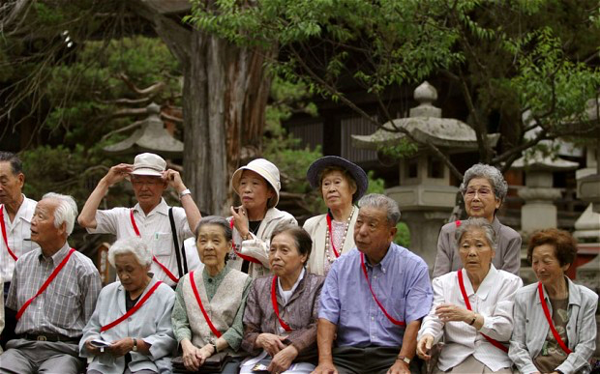

The Current Situation
In 2011, Japan had 22.9% of its population made up of over 65 year-olds (compared to 16% in the UK) and had a high dependency ratio of 59.8 (compared to 52 in the UK), meaning that every 100 workers had to support almost 60 people.

Japan’s birth rate has not been above 2 level since 1974.
Fertility rate: Ideally, the average number of children per couple should be 2.6, but currently this stands at 1.7 and at present trends, by 2050 there will be only 1.3 workers to support each senior.

What Will Happen Next
The situation will worsen over time since there are now fewer children to become workers. At the same time, the current population will age and more people will become pensioners. In fact, by 2055, the percentage of Japan’s population that is over 65 is expected to rocket up to 41%.

Problems This Will Cause
- The overall population will start falling: at the current birth rate (2014), Japan’s population will fall by a third over the next 50 years to 87 million.
- Some underused schools will start shutting down, so students will have to make a longer commute
- Reduction in spending into local businesses - smaller domestic market
- Less tax income for the government
- Higher spending for the government (the social security benefits is expected to almost double between 1995 and 2025)
- Lower standard of living
- Shortage of recruits for Japan’s armed forces
- Shortage of labour: the workforce, which measured 65.77 million in 2013, could drop by 42% by 2060 to 37.95 million
- Increased dependency on foreign workers (immigration) and potentially foreign goods (imports)

Strategies to Solve the Problem
2014: goal of maintaining the population at around 100 million over the next 50 years.

To increase workforce:
- The government began a programme which is aimed at enabling mothers to remain working (to earn enough income in order to maintain a good standard of living) while bringing up children at the same time
- Employers are allowing workers to continue working after they turn 65 years old
- A pro-natal population policy was introduced to try and encourage more births
- Japanese men are being encouraged to spend more time at home raising their children and doing housework to enable mothers to stay in the workforce
- Japan has become more open to immigration:strategic inclusion of foreign workers, including those with high-level skills,
- Encouraging more women in the workforce and retired people to keep working
- Government funding matchmaking and dating services to get more young people married and producing babies.

To cope with the increasing costs of an ageing population:
- The retirement age will moved from 60 to 65 years-old by 2025. Currently 62 years (2016) up from 60 years (2010).
- Taxes for the working population have risen
- A long-term care insurance scheme has become available

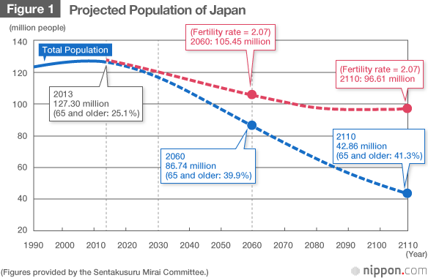

Ref: http://data.worldbank.org/indicator/SP.POP.DPND and http://data.worldbank.org/indicator/SP.POP.65UP.TO.ZS
https://www.nippon.com/en/features/h00057/

Population 1.2 Migration

- An international migration

Case Study of International Migration, Poland to UK:

- 831,000 Polish-born residents in the UK in 2015.
- Now the biggest source of migrants (2016)
- Increase of 850% of Polish migrants after they joined the EU in 2004

Push and Pull factors:
Push | Pull
Unemployment in Poland was 20% in 2004 compared to 5% in the UK  Youth unemployment of around 40%, rural unemployment in some areas of 40%. GDP in Poland was $12,700 per head compared to $30,900 in the UK  Earnings of around £600 per month in Poland compared to £2000 per month in the UK | Reduced living costs in the UK  By law and resident of an EU nation has the right of free movement amongst all of the other member states. A8 migrants are able to live and work in the UK without a visa – 293,000 new migrants  Higher salary, minimum wage in the UK is twice that of Poland. the government predicted an increase of 15000 migrants moving for employment in 2004  In 2004 the number of Poles at British Universities had tripled  Well established Polish communities

IMPACTS...
POLAND  Population fell (by 0.3% between 2003 and 2007) , birth rate fell as most people who left were young  Job prospects for those remaining behind will be improved as there are fewer competing for work.  Migrants often send money home, much of which is reinvested in the home economy.  Returning migrants bring back new skills, which may help to revitalize the home economy. £3 billion sent back in 2006  Less pressure on local resources, such as housing, food and education and health services  Population density is reduced  Returning migrants increase social expectations in the community, demand for improved leisure facilities  The loss of the young adult labour force may result in labour shortages  The loss of the most skilled and those with entrepreneurial talents, which may slow economic growth / negative multiplier effect  There may be an imbalanced population structure, with a disproportionate number of elderly, and fewer males, this can have long-term consequences. Family structure may break down.  Returning migrants may impose a social cost on the community if support mechanisms are not in place to cater for them, e.g. those returning home on retirement | UK  By July 2006 447,000 people for eastern Europe had applied to work in the UK, 62% were from Poland.  The polish embassy estimated the number of Poles in the UK to be between 500 and 600 thousand by 2008, this would mean the Poles would be the largest ethnic minority in the UK  £2.5 billion contributed to the economy by eastern European immigrants between 5% and 10% of UK growth in 2006 attributed to the same workers 80% of migrants between 18 and 35 years old helped cope with aging population problems  New migrants typically hard working, enthusiastic and flexible filled skills gap in the low paid job sector  Tensions in areas that have previously not experienced large scale immigration  Pressure on education where 427,000 migrant workers brought with them 36,000 young dependents  Some 27,000 child benefit application was approved. Stress on the NHS  Demand for housing led to high rents and prices  Wages returning to Poland  Exploitation on immigrants

Management:
Poland | UK
Immigrants from Poland now have to register under the worker registration scheme if they want to work in the UK
This lets the UK Border Agency monitor how many people are coming into the country, what type of work they do and its effect on the economy
Government tightened control of migration from some of the newer EU states

Population 1.4 Population density and distribution
- A densely populated country or area (at any scale from local to regional)

DENSELY POPULATED AREA:
SOUTH EAST ENGLAND

Nearly 1/3 of UK population live in SE England & London. Population is 19 million including Greater London, 8.5 million without. Population density is very high at 964 per square kilometer (including London) 450 without

Access to 4 major international airports, M25 and major arterial routes to UK and Europe

Gentle relief and good soils, milder climate and abundant water supply make the region historically good for both arable and mixed farming

Job opportunities in Service and tertiary sectors. Biggest economic area outside London: £177 billion in 2006

GDP per capita second largest in UK

Historically a region of early settlements but also 19th century trade e.g. Chatham and Rochester

Quality of life considered very good with top universities and funding, proximity to capital and high levels of education

Population 1.4 Population density and distribution
- A sparsely populated country or area (at any scale from local to regional)

Sparsely Populated area: Scottish HIghlands

Highlands have a population density of just 9/ square kilometre. Makes up half of Scotland’s area but just 1/9 of population.

Population declined rapidly after the ‘Highland Clearances’ in 16th century

During the Industrial Revolution (early 19th century) many Highlanders moved to Glasgow in serach of factory/ docklands work and better pay

Remote and hard to access including many islands meaning: few jobs, little chance to develop industry, fewer services e.g schools and shops. There are few large settlements for jobs and services.

It has a more inhospitable Taiga biome of Scottish pines due to poor soils and colder climate making arable farming very poor

Much of land belongs to a few wealthy landowners and only ‘crofters’ were allowed to farm e.g. sheep and peat on Skye

Very steep relief (many mountain ranges) making accessibility and farming very difficult.
……………………………………………………………………………………………………………

SETTLEMENT TOPIC

1.5 Settlements and service provision

- Settlement and service provision in an area

Case study: settlement hierarchy and service provision in an area: South Cambridgeshire

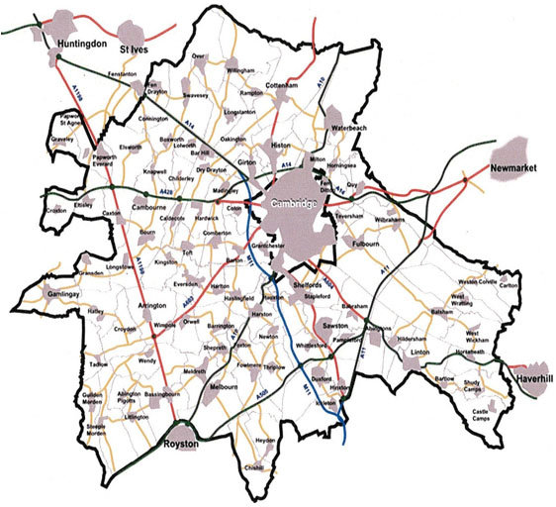

Settlement hierarchy

- Cambridge is the single main city of S Cambridgeshire. It has a population of 130,000
- It has 5 towns within a 10 mile radius, 3 of which are actually outside the borders of Cambs. Royston (Herts), Haverhill and Newmarket (Suffolk)
- It has over 50 villages and over 150 hamlets and its sphere of influence extends farthest to the East where the nearest city is Norwich over 60 miles away. It’s theatre and shops attract visitors from all over south Cambridgeshire while in a sense it has a global sphere of influence due to its tourist attractions
- Although it is smaller than Peterborough (pop 183,700) Cambridge has a bigger sphere of influence as it has a much higher proportion of high order services and more significant educational, historical and cultural functions

Service provision and hierarchy

Name & type of settlement and position in hierarchy | Population  (Year) | Function(s) | Service provision
1.Cambridge (city) | 125,000 (2011) | Historical, civic, education, tourism, science & technology, residential, retail, commercial | Transport: airport, 2 rail stations (Cambridge North in 2017), roads (M11, A14)  Education: 2 universities, 4 sixth form colleges, 10+ secondary schools, 15+ primary schools  6 Museums  3 theatres  2 major shopping centres (Grafton and Grand Arcade)  2 retail parks  5 science parks including Milton
2. Huntingdon (town) | 23,700 (2011) | Residential, commercial | Transport: 2 rail stations  Road: A 14  Fire station, police station  4 primary schools  2 secondary schools, 1 6th form college  1 shopping centre  Out of town industrial estate
3.Duxford (village) | 2010 (2011) | residential | 3 pubs, 2 churches, 1 garage, 1 primary school, 1 shop, 1 beautician, bus stop
4. Six Mile Bottom (hamlet) | 83 (2006) | Residential, agricultural | 1 pub, 1 community centre, minor roads, no bus stop

Settlement 1.7 Urbanisation

- An urban area or areas

CASE STUDY: CAMBRIDGE

Settlement 1.7 Urbanisation

- A rapidly growing urban area in a developing country and migration to it

CASE STUDY: MUMBAI: A rapidly growing urban area in a developing country and migration to it

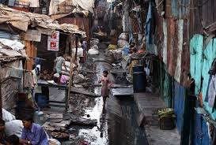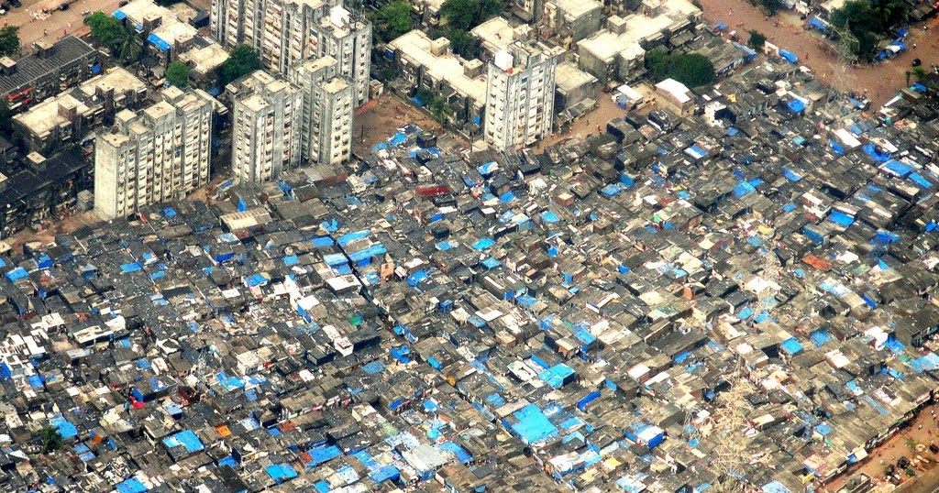

How fast is Mumbai growing?
Mumbai is India's largest city by population (Mumbai's Urban Agglomeration is 20.7million, while the city itself was recorded at 12.48 million in 2011).
In 1911 its population was just 1 million, in 1951, 3 million, by 1991 it was almost 10 million and it has doubled in size since then
The financial capital of the country, being home to the Mumbai Stock Exchange.
Up until the 1980s, Mumbai owed its wealth to its historical colonial past, textile mills and the seaport, but the local economy has since been diversified
Mumbai is now home to most of India's specialised technical industries including aerospace, optical engineering, medical research, computers and electronic equipment of all varieties, shipbuilding and salvaging, and renewable energy.
Mumbai serves as an important economic hub of India, contributing 10% of all factory employment and 40% of India's foreign trade.

Why is Mumbai growing?
- HIgh rate of natural increase due to high BR, high proportion of population being of reproductive age population and increasing life expectancy. Economic, socio-cultural and religious reasons mean birth rate remains high.
- Rapid rate of urban to rural migration due to push and pull factors (see below) and the mechanisation of farming/ shift from primary to secondary industry.

PUSH FACTORS (pushing people away from rural communities
Economic
1. The Green Revolution (a government programme to improve agriculture) has reduced farm work in rural areas as more machinery is now used. Also high yielding seed varieties were introduced needing lots of fertilizer and pesticides. Only large farms can afford the chemicals and machinery. Many small farms cannot compete and people have sold up. Farm jobs have become harder to find and those that remain are incredibly poorly paid, often with only casual hours available.
2. Population growth in rural Maharastra has been rapid. In India the tradition is for a father’s land to be divided equally between his sons. This has led to people farming plots of land which are too small to support a family and malnutrition occurs. Incomes are very low and it is hard to clothe and house and feed more children. There is malnutrition and overcrowding. Due to the lack of land people have farmed land in unsuitable areas (e.g. too dry) and areas have suffered soil erosion becoming difficult to farm.
Social Factors
1. Educational and health standards are much lower in rural areas because it is hard to get teachers and doctors to work in the impoverished countryside. They want to work in towns where living conditions are better.
2. Young people see farming as hard work with long hours and low pay. It provides few prospects of a better life in the future.

PULL FACTORS (Drawing people into Mumbai)
Economic
1. Job prospects in Mumbai. The traditional industries of textiles, shipping & freight and jobs brought by TNCs. Mumbai is the financial capital of India and many Indian companies have their headquarters there. All these jobs promise to offer higher pay than farm work but the reality is often that skills are required to take some positions that the majority do not have.
2. Investment by the Mumbai Metropolitan Authority, the Indian government and international agencies e.g. the UN in public works e.g. improving water supplies offers the potential of employment in public services.
Social Factors
1. Mumbai has some good schools and universities as well as decent hospitals and dentists. If you can access these services your quality of life will be higher than in the countryside.
2. In Mumbai your home is more likely to have services such as water, electricity and sewage. These increase living standards and so are attractive to prospective migrants.
3. Many migrants will already know people who have left the countryside to go to the city. They hope that these contacts will help them to find work and housing etc.

What problems is Mumbai facing?

- Air pollution
- Release of CO₂ into the atmosphere from heavy traffic, unregulated industry and slum fires decreases localised air quality but more widely contributes to climate change across the world.
- Particulate matter is where the air is full of small particles of dust or material which is scientifically linked to respiratory diseases such as bronchitis and even cancer.
- It has also been linked to death in sensitive bird species like the white beaked woodpecker.
- Smogs are common with a severe smog in January 2018. In late October 2013, the visibility was reduced to less than 500 metres in some parts of the city by particulate matter.
- In 2016 Mumbai recorded an annual average air pollution over five times WHO's safety limit
- Water pollution
- Untreated Sewage discharged into rivers…
- Toxic industrial waste entering waterways
- Bioaccumulation of pollutants in fish.
- Illegal dumping of toxic waste and rubbish
- Flooding/Flood Risk. 2005 floods due to heavy rain saw 1090 deaths and severe contamination from raw sewerage
- Severe congestion means it typically takes 2 hours to get from outskirts to city centre causing a longer commute, air pollution and smog. 700,000 cars on the road,
- 7,000 metric tonnes of refuse is spewed out each day.
- 7.5 million commuters cram themselves into local trains every day
- Lack of green space. less than 0.03 acres of open space per 1,000 people. The global average is 4
- 1 in 6 Mumbai residents live in a slum
- Overcrowding. In Dharavi the population density is 1 million per square mile.

Dharavi Slum (urban issues in an LEDC)
There are a million people crammed into one square mile in Dharavi.
At the edge of Dharavi the newest arrivals come to make their homes on waste land next to water pipes in slum areas. They set up home illegally amongst waste on land that is not suitable for habitation. In the wet monsoon season these people have huge problems living on this low lying marginal land.
Many of the people here come from many parts of India as a result of the push and pull factors of migration.

Conditions in the slum
- The annual turnover of business here is estimated to be more than $650m (£350m) a year, however the average wage in this region is between 100 and 500 rupees a week, so the wealth does not filter down to the inhabitants.
- A few schools exist, but these are very overcrowded and many of the slums population are too busy working earning money to help support their families to become well educated.
- There are three hospitals but they are poorly equipped and many don’t have proper access to medical help and support.
- 500 people share one public latrine. People have to go to the toilet in the street and there are open sewers.
- Children play amongst sewage waste
- doctors deal with 4,000 cases a day of diphtheria and typhoid. Next to the open sewers are water pipes, which can crack and take in sewage.
- Dharavi slum is based around this water pipe built on an old rubbish tip.
- The people have not planned this settlement and have no legal rights to the land.
- There are also toxic wastes in the slum including hugely dangerous heavy metals
- Dharavi is made up of 12 different neighbourhoods and there are no maps or road signs. The further you walk into Dharavi from the edge the more permanent and solid the structures become.
- People live in very small dwellings (e.g. 12X12ft), often with many members of their extended families.
- Water is a big problem for Mumbai's population, standpipes come on at 5:30am for 2 hours as water is rationed. These standpipes are shared between many people.
- Rubbish is everywhere and most areas lack sanitation and excrement and rats are found on the street.
- sewage water filters into the water used for washing clothes.

Solutions to Mumbai’s problems

- REDEVELOPMENT SCHEME
The plan to improve Dharavi is called Vision Mumbai.
This involves replacing squatter settlement housing with high quality high-rise tower blocks of flats.
The Indian government also wants to add basic services, more schools, health centres, shops, better roads and more jobs.
The improvement of Dharavi has not yet begun due to costs (estimated at about £2 billion) and the size of the problems.

Advantages
- 72,000 families re-homed
- More sanitary/ clean- plumbing
- = less illness= less healthcare (an expense)
- Strengthen road networks
- =Businesses attracted= better paid jobs
- Improve education = more money made in the future
- Live and work in separate places= better health/ less cramped
- $3000 per year generated from new commercial/ industrial areas.

Disadvantages
- 28,000 families without home
- =Possibly make new slum somewhere else.
- Flatten slum
- Ugly cramped high rises
- New buildings too small (5-10 people get 21 square meters)
- Ruin slum culture
- People like working/ living in same area
- Slum dwellers now have to pay tax

Other solutions
- Monitoring fishing in the lakes and dissecting and analysing pollution content in fish has now been set up in Mumbai to help stop its population consuming contaminated and poisonous fish species.
- Water Quality monitoring has now been implemented in 3 of the most contaminated lakes.
- Remaining areas of agricultural land are being protected from development by the Indian Government. (E.G the Creation of the Sanjay Gandhi National Park).
- The Society for the Promotion of Area Resource Centres, better known as SPARC, this is an NGO that supports the efforts of local people to get better housing for their many members. Ideas generated from local people supported by this charity include adding an extra floor to buildings so that all family members can be accommodated in the same building. These flats also had 14-foot high ceilings and a single tall window so are well ventilated, bright, and less dependent on electric fans for cooling. Their loft spaces add extra room without seeming crowded, and include small spaces for bathing. But toilets are placed at the end of each of the building’s four floors, and kept clean by the two or three families who use each one. These ideas only work when water is running in Dharavi.
- As the National Slum Dwellers Federation has repeatedly proven, housing the poor works best, costs less and is better for the environment, when the poor themselves have a say in what is being built.

GENERAL Slum challenges:
- Risk of eviction. Most of the land they are built on is illegally occupied so they could be thrown of it at any time.
- No proper electricity connections leading to illegal and dangerous connection to the city's electricity supply
- Housing that is only made out of temporary material which is vulnerable to flooding, etc.
- No clean water supply which can lead to diseases like typhoid.
- Overcrowding (high population density) which allows diseases to spread quickly
- No toilets, showers or proper sewer systems which can cause disease to spread and attract mosquitoes which cause diseases like malaria
- No proper rubbish collections which can attract animals like rats
- No proper schools and medical facilities
- Shortage of entertainment and facilities for all ages
- High unemployment
- High crime rates, including gangs, drugs and murders

https://www.theguardian.com/cities/2014/nov/24/mumbai-verge-imploding-polluted-megacity
http://www.coolgeography.co.uk/GCSE/AQA/Changing%20Urban/Shanties/Squatter%20settlements.htm

https://getrevising.co.uk/grids/geography_dharavi_redevelopment_scheme
http://worldpopulationreview.com/world-cities/mumbai-population/

……………………………………………………………………………………………………………………………………..

EARTHQUAKES & VOLCANOES TOPIC

2.1 Earthquakes and volcanoes

- An earthquake

Case study of an Earthquake: SENDAI, JAPAN 2011

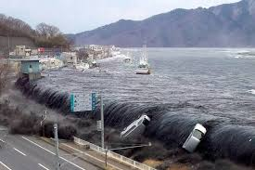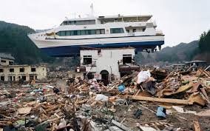

Summary

DEATH TOLL  HOMELESS  MAGNITUDE  FOCUS DEPTH  EPICENTRE  TYPE OF PLATE MARGIN  TSUNAMI | 15,900  230,000  9.0 on Richter Scale, over 500 aftershocks along the fault  32 km (fairly shallow)  Sendai 129km east of epicentre which was out to sea  Destructive subduction: Pacific Plate subducting under Eurasion plate  Japan is used to earthquakes. Buildings & infrastructure better. The tsunami was the deadliest secondary effect as it hit densely populated coastal areas but had a few minutes warning…saved lives  Nuclear accidents= secondary effect

Causes:
- Boundary of 3 different plates
- Destructive (subduction) plate boundary
- Pacific (oceanic, more dense) tectonic plate has been subducting under the Eurasian (continental, less dense) plate for 200 years to the east of Japan
- Process of subduction is not smooth
- Friction causes the Pacific Plate to stick. In the case of Japan pressure built up and on 11th March 2011 this pressure released as an intensely strong earthquake (9.0 on the Richter Scale) and a tsunami with waves of 30m travelling at a colossal speed of 800km/hr which is equivalent to the ground speed of a jumbo jet
- It was followed in places by up to 9 additional waves up to 10m in height.
- 3000km of coastline was affected by the tsunami, which tore through coastal defences
- Nearest city to epicentre was Sendai (130km east of Sendai) and 373km north of Tokyo. First to be hit by Tsunami
- A tsunami warning extended to at least 50 nations and territories, as far away as South America

Impacts:
Primary | Secondary
- 15,900 people killed  - 230,000 people homeless from the 10m high tsunami which passed over the defensive sea wall- only 9m high  - 4,700 destroyed houses  - 50,000 damaged houses  - 582 roads cut off  - 32 bridges destroyed  - 4 trains swept away from their tracks  - A cruise ship carrying 100 people was washed away by the force of the wave  - 1800 homes in the town of Minimosa destroyed and 1/3 of the city of Kensennuma was under water  - A dam in the north of Fukishima burst its banks, which caused homes to be swept away  - Power lines, gas and water services were severely disrupt red as the earthquake ruptured underground cables  - Public telephone systems knocked out with no signal for mobile phones and internet  - 28 million tonnes of debris  - 500km2 coastal plains hit, destroying farmland, settlements and communications. | - 500,000 people forced to live in shelters  - The disruption caused to rail and road links meant that it was hard for rescue teams to reach places where it was needed  - The damage to the underground gas pipes led to fires which spread quickly and ignited wood carried by wave  - As clean water was scarce, water borne diseases spread quickly such as Chloera  - The earthquake caused a power cut at Fukishima Daiichi Nuclear Power Plant which caused a failure in its cooling systems and subsequently caused radioactive materials to escape causing local radioactivity level to increase but up to 40,000 x more than normal  - Japan lost £90 billion in its shares  - Total cost to rebuild affected areas was £185 billion  - 4 million homes in and around Tokyo suffered. power cuts  - Further problems were caused by heavy snow and blocked roads.

Response:
Short Term | Long Term
- Within minutes of the Tsunami, Japan altered its energy response teams – 300 planes and 40 ships from the military  - An estimated 100,000 people began the disaster relief mission  - The Japanese Red Cross mobilised 230 emergency teams to the worst affected areas to provide medical and moral support  - On the 2nd April, Japan and USA joined forces to search for the bodies along the east coast  - Shelters were set up in schools for those who lived in close proximity to the power plant  - Many NGO’s responded for example Shelter box sent 1,500 boxes of aid within the first month of the disaster  - The PM visited each disaster zone by helicopter | - In March, Japan’s meteorological agency issued on earthquake warning, followed by a tsunami warnings  - This meant that many people were able to escape to higher ground, but the short (20 minutes) meant that thousands could not escape  - The Japanese government responded to this disaster by questioning their huge walls and Tsunami flood gates as they were not efficient  - March 2012 year after 330,00 living in temporary accommodation  - The government also responded to this disaster by reviewing their methods on predicting earthquakes and tsunamis and cutting response times  - Improving communications and sirens

2.1 Earthquakes and volcanoes

- A volcano

VOLCANO case study: Mt Soufriere, Montserrat 1997
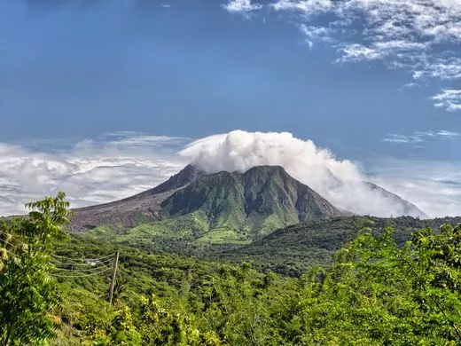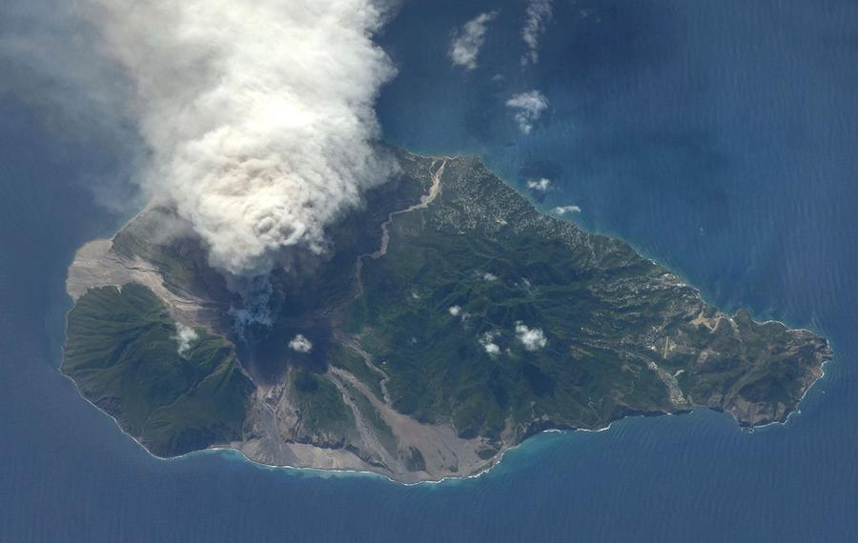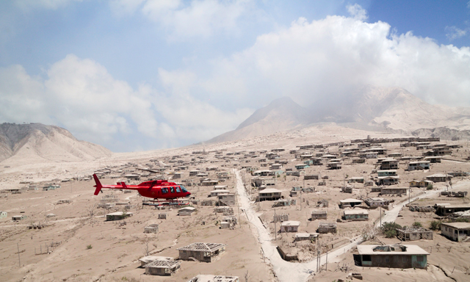

Causes of Eruption
The island has been created because the Caribbean Plate and Atlantic Plate are moving towards each other and the dense oceanic plate is being subducted under the lighter continental plate.

At destructive boundaries oceanic crust is destroyed as it is forced below the less dense continental crust. The partially melted rock forces its way to an area of lower pressure ready to erupt.

Before 1995 Mount Soufriere had been dormant for over 300 years.

In 1995 the volcano began to give off warning signs of an eruption (small earthquakes and eruptions of dust and ash)

In 1997, Large eruptions continued with the dome collapsing and large pyroclastic flows affecting much of the island

Primary and Secondary effects of the Eruption

The Primary Effects of the Eruption | The Secondary effects of the Eruption
- 2/3 of the island was covered in ash  - 50% of the population were evacuated to the north of the island to live in makeshift shelters  - 23 people died in 1997  - Volcanic eruptions, pyroclastic flows and lahars have destroyed large areas of Montserrat. The capital, Plymouth, has been covered in layers of ash and mud.  - Floods as valleys were blocked with ash  - The airport and port were closed  - Farmland was destroyed and forest fires caused by pyroclastic flows  - Many schools and the only hospital was destroyed | - As most of the southern area was destroyed any remaining inhabitants have had to endure harsh living conditions in the North.  - Transport remains a problem for people travelling to the island as the port and airport remain closed.  - The tourist industry is still suffering with few visitors except for cruise ships looking at the volcano  - Over half the population left the island and have not returned  - Much of the island is still uninhabitable  - Before the eruption of 1995, over 12,000 people lived on the island but less than 5000 do today.

Responses to the Eruption

Short-term responses

- Evacuation of the southern part of the island
- Abandonment of the capital city.
- The British government gave £41 million in aid although riots occurred as locals complained that the British were not doing enough to help the island money for compensation and redevelopment.
- Unemployment rose due to the collapse of the tourist industry.

Long-term responses
- Money was given to individuals to help them move to other countries.
- An exclusion zone was set up in the volcanic region.
- New roads and a new airport were built.
- Services in the north of the island were expanded.
- The presence of the volcano resulted in a growth in tourism.
- The MVO (Montserrat Volcano Observatory) was set up to study the volcano and provide warnings for the future
- A Risk assessment was done to help islanders understand which areas are at risk and reduce problems for the future.

RIVERS TOPIC

2.2 Rivers

- The opportunities presented by a river or rivers, the associated hazards and their management

Case study of a river: the Mississippi
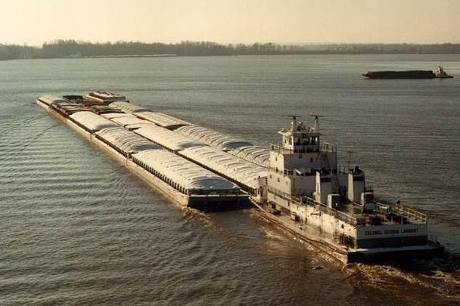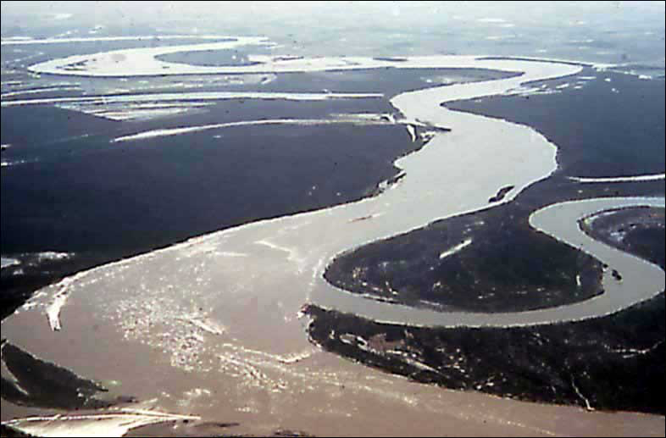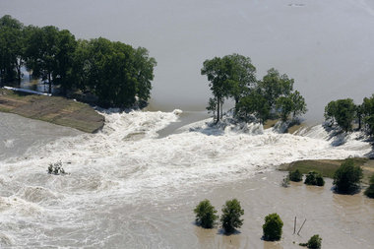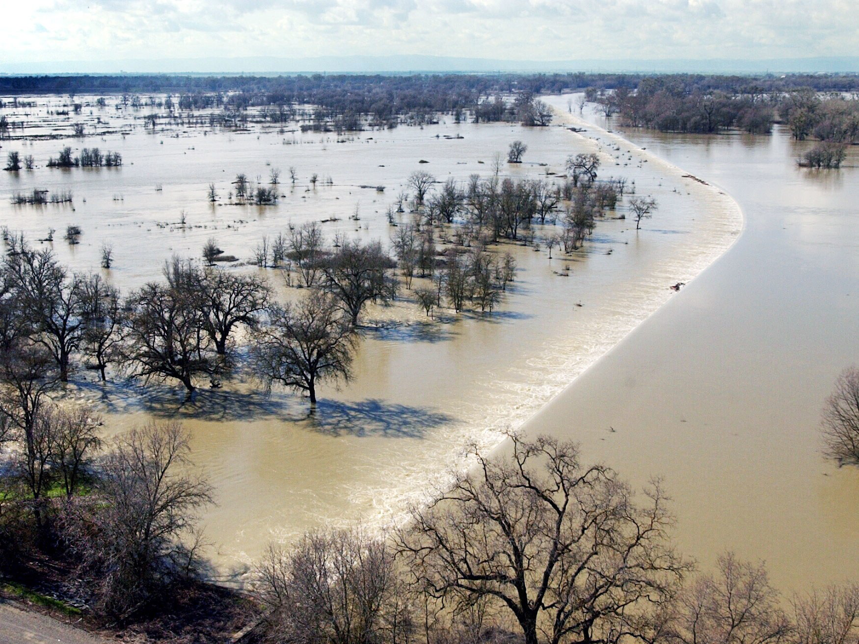

- - Length - 3,800 km
- - Width - Flood Plain is 200 km wide at its widest point
- - Releases 600 million tonnes of sediment of load each year (into the sea and along its course)
- - Flows through 10 states
- - Carries 13% of all freight traffic in the USA

1. What Economic Opportunities are Offered by The River Mississippi?

- - 11 million tourists each year in the upper reaches of river
- - tourism contributes $1.2 Billion to the economy each year
- - Sports Fishing - $100 milling, Waterfowl hunting - $58 million
- - 29 power plants provide energy to vast array of factories and homes
- - Water from river used for cooling in 80% of Energy Production Facilities
- - Silt deposits formed on huge flood plains made area around the river among the most fertile
- regions of the USA (sugar canes, rice, tobacco, and cotton plantations)
- - River provides main transport routes for exports around the world
- - Today over 100 million of commodities transported down the river every year (including 56%
- of the nation's corn, and 41% of soybean exports)

2. What problems/hazards are Presented by the Mississippi?

- - Despite efforts there has been major floods over the last 50 years
- - Particularly severe flood in 1993 (see below)
- - Many people live along the river's flood plains
- - Many scientists have argued that overflowing in a natural part of the river, and should be left to
- happen (prevention measures should be abandoned)
- - One of the worst areas of flooding is the point when the rivers enters its delta at the Gulf of
- Mexico and spreads through distributaries e.g. Hurricane Katrina storm surge at the mouth of the Mississippi in New Orleans
- - Careful management is needed to stop the build-up of sediments causing even more floods
- - The river’s length of 3,800 km means that it's very difficult to prevent flooding
- - needs constant dredging to allow for ship traffic

“Great flood of 1993”
- Between April and October 1993
- 30,000 square miles flooded
- Affected both the Missouri river (tributary of Mississippi) and Mississippi basins
- Caused by a series of storms with heavy rainfall (less time to absorb into the soil or infiltrate) throughout period, in some places 750% more rainfall than usual with rainfall amounts of (125 to 175 mm) in 24 hours
- Lower than average temperatures (less evaporation)
- By the beginning of June the ground was already saturated meaning that continued rainfall went straight into river systems
- St. Louis, river levels were nearly 20 feet (6 m) above flood stage.
- 700 privately built agricultural levees were overtopped or destroyed along the Missouri River.
- Navigation on the Mississippi and Missouri River had been closed since early July resulting in a loss of $2 million (1993) per day in commerce.
- Approximately 100,000 homes were destroyed as a result of the flooding, 15 million acres (60,000 km²) of farmland inundated
- 32 people died
- Approximately $15–20 billion in damages
- River levels breached levees and floodwalls (levees)

3. What Managements/Solutions Have Been Tried/Planned for The River?

https://www.bbc.co.uk/education/clips/z3bqxnb

Dams, spillways, artificially strengthened levees, river straightening, flood warning systems, afforestation

- - 6 dams along the Missouri, 1600km chain of 105 reservoirs: these hold back water until river levels have lowered and can manage more water
- - 9 dams have been built along the Tennessee river (also a tributary)
- - Afforestation in the upper Mississippi drainage basin system: planting of trees increases interception and increases lag time
- - The Bonnet Carré floodway (9km long spillway) diverts excess water from the Mississippi, 50km north of New Orleans
- - River straightening e.g. one 530 km stretch of river has been shortened by almost 300 km by cutting through meanders. This increases the gradient and speed with which flood waters can be carried away.
- - Reinforced levees using concrete blocks: success in St Louis in 1993 as river levels almost reached the full height of levee but it just managed to hold them back

http://askmichellegeography.blogspot.co.uk/2012/03/mississippi-flood-defence-scheme-case.html

COASTS TOPIC

2.3 Coasts

- The opportunities presented by an area or areas of coastline, the associated hazards and their management.

COASTS CASE STUDY: North Norfolk coast
(Cromer, Overstrand and Happisburgh)
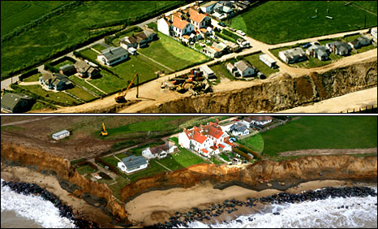

45 miles of coastline, including some of the most rapidly eroding coastline in the world (averages 2m/ year)

Opportunities:
- A UNESCO biosphere reserve until 2014. An area of wetlands and salt marshes and an important habitat for wildfowl and marine animals including seals (Blakeley Point (spit)– an area of outstanding natural beauty). Attracts a large number of tourists for birdwatching
- Tourism includes visiting beaches and attractions such as the pier at Cromer. Over 25% of jobs (over 10,500 jobs) are now in tourist sector bringing in a total of £470 million in 2014.
- The coastline offers opportunities for the harvesting of mussels, cockles, shrimps, crabs, and bait as well as some commercial shore-netting e.g. Cromer Crab
- There are a number of field study centres for educational visits such as Aylmerton Study Centre and Holt Hall
- Some areas are cultivated for sugarbeat and cereals.
- Off-shore wind farm. 88 turbines off the coast of Sheringham.
- Reclaimed land at Blakeley Point is used as pasture and a nature reserve

Causes of erosion:
- Geology: soft, impermeable clay base with soft, permeable gravel above.The impermeable clay traps water percolating through cliffs, causing it to pond and discharge from the cliff face. This leads to an increase in pressure in the cliff, reduced strength of the cliff, which may cause landsliding/ slumping caused by weathering
- As the cliffs are made of soft varied materials with a low resistance this also means that they are very vulnerable to wave erosion and mass movements caused by undercutting, sometimes as much as 10m in one go
- Waves have a long fetch (North Sea).
- Main sea defences (revetments) destroyed in 1990 storm
- Government is enforcing a Do Nothing Policy of managed realignment.
- Narrow beach, unable to absorb much wave energy
- Sea wall to the North at Cromer, Overstrand prevent erosion there and therefore reduce available sediment that could be deposited by LSD at Happisburgh
- Dredging at Yarmouth to the South also deprives Happisburgh of sediment by LSD.
- Granite reef at Sea Palling restricts sediment movement.

Problems/ consequences
- Coastal erosion and cliff recession: Happisburgh & Overstrand. Very severe. Averages 2-5m per year at Happisburgh.
- At Happisburgh: over 26 houses lost to the sea
- Homeowners cannot take out insurance.
- Homes become unsellable / lose value.
- Coastline permanently disappearing.
- Wave action can undercut these cliffs making them prone to failure, especially on low cliffs (10 metres or so), such as at Happisburgh
- problem area - Beach Road runs out to the cliffs and properties here are situated right on the cliff edge
- in 1990 a storm destroyed around 300 metres of wooden revetment to the east of Happisburgh
- in 1996 another length of revetment was lost - rapid cliff erosion followed and six cliff top properties were lost
- at the base of the cliff there is a combination of gabions/flexible concrete blocks/3" steel tubes banded together to lie in a breastwork
- They have also tried groynes and most recently, rock armour.
- Flooding at Blakeley Point. 1953 especially severe (307 killed)
- River Glaven becomes blocked by shingle from advancing spit and floods Cley village.

Action: Happisburgh
- Coastal Concern Action Group set up to lobby North Norfolk District Council.
- North Norfolk District Council gave £200,000 in 2006 for 5,000 tonnes of boulders as rip rap / rock armour..
- Villagers raised a further £50,000 for a further 950 tonnes of boulders.
- This bought the village a 10 year reprieve.

Actions elsewhere:
- The River Glaven has been diverted to prevent recurrence of floods
- Sea walls with promenades have been erected along the coast at Cromer and Overstrand with wooden groynes to keep beach, gabions and some rock armour
- Some revetments at Cromer have helped create a beach
- Beach replenishment by offshore dredging

CLIMATE & VEGETATION TOPIC

WEATHER TOPIC

2.4/ 2.5 Weather, Climate and Vegetation

2.5 An area of tropical rainforest

Equatorial Forest Case Study: Borneo Climate & Deforestation
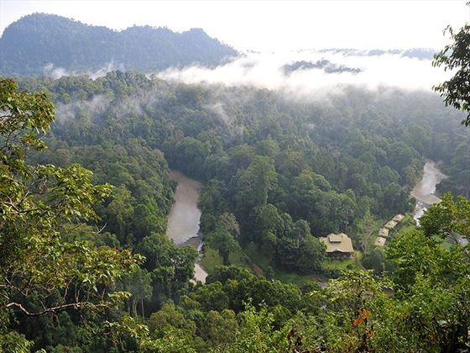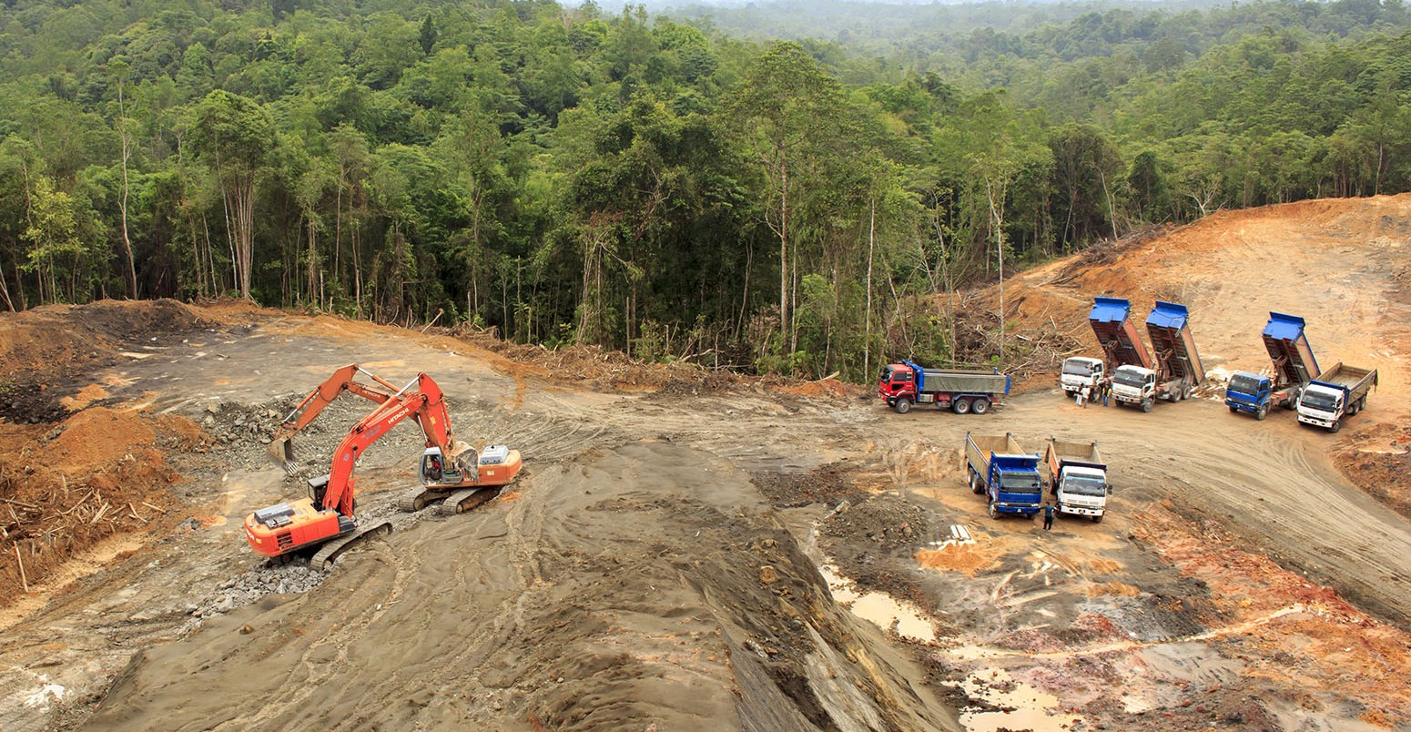

CLIMATE

The Sabah region of Borneo has an equatorial climate and is generally warm and humid all year round.

Temperatures averaging 27°C to 32°C, rarely rise above (32°C). Relative humidity is usually 70-85%.
Diurnal range is low, (3 to 4 degrees) slightly higher in areas of higher altitude.

Rainfall is common throughout the year, and varies from 150 cm to over 450 cm per year. In most parts of Sabah the wettest months occur from October through February and the driest months during from March to September. That said, there is often there is no significant division between the two "seasons."
Latitude: near the Equator so the sun’s rays travel through a small amount of atmosphere therefore allows more insolation (solar radiation) to reach the surface = high temperature
Heavy cloud cover means few rays are reflected back out to space = high humidity and low diurnal rang

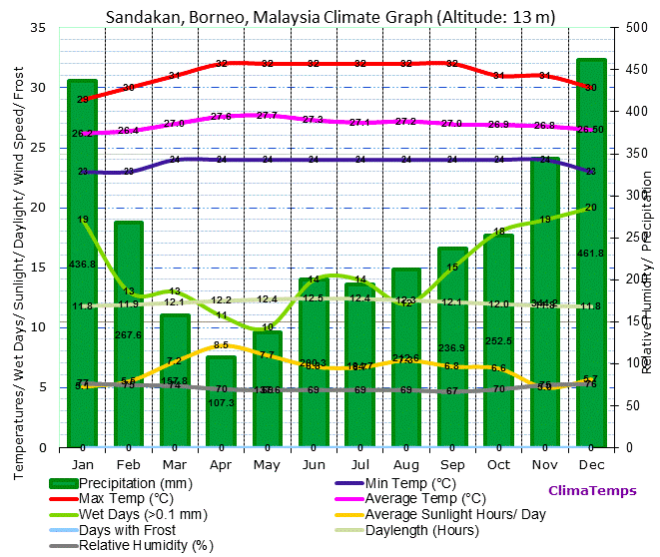

Fauna and Flora

There are about 15,000 species of flowering plants
3,000 species of trees
221 species of terrestrial mammals
420 species of resident birds
440 freshwater fish species
Last remaining habitat of orangutan
Home to the Sumatran rhinoceros

Emergent’s Layer | The Capuche tree is an individual tree with open space around. It reaches 40m high.  Hot and windy. Wind causes evapotranspiration which robs the leaves of moisture.  Leaves are smaller to reduce this. Trees are wind pollinated so they are fluffy.  Little animal life only eagles
Canopy Layer | Dark and humid  Trees have pivoting leaves which follow the sun across the sky. Very large leaves to maximize photosynthesis.  little space so plants grow on tree branches, called epiphytes e.g. Orchid  high biodiversity such as parrots humming birds, insects and monkeys
Under Canopy Layer | little vegetation, bare trunks, no leaves  All energy is focused on reaching the canopy layer to photosynthesise otherwise they die. Lianas grow around the tree.  Snakes and insects use the tree trunks as transport links form the ground upwards
Shrub Layer | Thin in fertile soil due to lack of sun light and leaching  Buttress roots hang 2-3m high above the soil to stabilise them in high winds  Hot and humid which encourages the growth of bacteria and fungi

http://www.wildland.com/destinations/asia/borneo/seasonsclimate.aspx

DEFORESTATION OF TRF IN BORNEO

http://www.borneofutures.org/deforestation.html

Scale:
- The region has lost over half of its forests, and a third of these have disappeared in just the last three decades.
- Current deforestation rate of 1.3 million hectares per year
- deforestation is accelerating and more than 8 million hectares were lost between 2000 and 2010, accounting for 12 percent of its 2000 cover
- Borneo TRFs are said to be 130 million years old, the oldest on the planet.

Causes of deforestation
- TIMBER: over 29,000 km² of TRF in Kalimantan (Indonesian Borneo) were cut down between 1985 and 2001 to supply global timber demand.
- Most timber is logged illegally as protection laws are poorly enforced
- COAL (mining)- Kalimantan holds 53% of Indonesia's recoverable coal reserves
- MINERALS (mining) Borneo is rich in tin, copper, gold, silver, & diamonds
- Palm Oil plantations: palm oil production expanded from 600,000 hectares in 1985 to over 6 million hectares by 2007
- a growth in illegal wildlife trade, as cleared forests provide easy access to more remote areas
- Illegal logging: some 56% of protected lowland tropical rainforests in Kalimantan were cut down between 1985 and 2001 to supply global timber demand
- Additional 10% deforested for agro-industrial crops (about 10 % of the entire Borneo island) mostly rubber trees or acacias for the pulp and paper industry
- mining (for coal or for gold and other minerals),
- infrastructure development (roads, human settlements, etc.)
- Fires can cause extensive damages during El Nino-related drought events

Impacts:
Global Warming and Health | - Burning forest emits a lot of CO₂ into the atmosphere which absorbs radiation and contributes to global warming  - When forests are removed less O₂ is given off  - Smoke from burning forests is also a health hazard, responsible for one in five deaths in South East Asian Island region.  - Deforestation and forest degradation account for up to 20 per cent of global man-made CO2 emissions.
Biodiversity | - Loss of plant species which could have been used for medicines and raw materials in industry  - A 2010 TRAFFIC report estimated that one group in the Malaysian state of Sabah was responsible for taking 22,000 pangolins over 18 months.  - In Japan, the Super Red Arowana can fetch prices ranging between $2,000-$200,000
Death of life and Culture | - Forest clearance in Sarawak for HEP development, oil palm plantations and logging may threaten hunter gatherer way of life for the Penan People who feed on the fruits and nuts and animals in the area  - 56% of protected lowland tropical rainforests in Kalimantan were cut down between 1985 and 2001 to supply global timber demand  - In Kalimantan, the Dayak people are also under threat. They are shifting cultivators who need to be able to move to different areas of the forest once their current plot has had its soil leached. When there is plenty of forest this is sustainable. Now deforestation is forcing them to return to each plot before sufficient years of fallow have passed. As a result crop yield deteriorate.  - Tension between the Dayak and the migrants who were moved to Kalimantan  - Account for over 90 per cent of the world's total oil palm production area Indonesian government has responded by setting a target to increase oil palm production from 20 million tonnes in 2009 to 40 million tonnes in 2020.oil palm production expanded from 600,000 hectares in 1985 to over 6 million hectares by 2007.
Habitats | - Numbers of orang-utan have fallen 50% in the last 50 years due to reduced forest cover. Poaching is easier. Sold as pets.
Soil Fertility | - Cleared land is intensely farmed, loses fertility within 20 years.  - Kalimantan holds 53% of Indonesia's 4,300 million tons of recoverable coal reserves, and Sabah and Sarawak hold 99% of Malaysia's 1,724 billion tons of coal deposits.  Borneo also holds rich metal and mineral resources, including tin, copper, gold, silver, coal, diamonds, and different types of sand and stone.  Together, the forestry and mining sectors are the main contributors to forest loss in Borneo.

Management/ solutions
General | Some areas of Borneo have been designated as national parks, for example, when Kutai National Park was formed in Kalimentan, over 300,000 hectares of forest where made safe from development
Selective Logging | Businesses operating in the area have already taken steps to locate and manage their operations more sustainably.  For example, of the 8.6 million ha allocated in concessions within the Heart of Borneo, 8% of this area is already certified by the Forest Stewardship Council (FSC) or the Roundtable on Sustainable Palm Oil (RSPO), indicating that they are already being sustainably managed.  Individual trees are felled only when they are mature so that the canopy if preserved which protects the ground below  Every tree is selectively logged, up to 30 other trees can be damaged or destroyed getting the logged tree out of the forest
Reducing Debt | Conservation swaps. A country that is owed money by another country cancels part of the debt in exchange for an agreement by the debtor country to pay for conservation activities there.
Promoting responsible Management and Use | The forest and Land Restoration Initiative in Kalimentan has started an aim to restore 900,000 hectares of forest each year by afforestation and reforestation. It involves local government and villagers. Teak is planted as it is valuable and fast growing so can be logged sustainably.  Incentives are given to local farmers to replant trees but they are often not big enough to achieve that aim
Ecotourism | The Tabin Wildlife Resort in the north of Borneo is a wildlife reserve. Rungs are spread across the canopy and ground level for visitors yet does not disturb the wildlife.

2.5 An area of tropical desert

Tropical desert case study: Namib desert

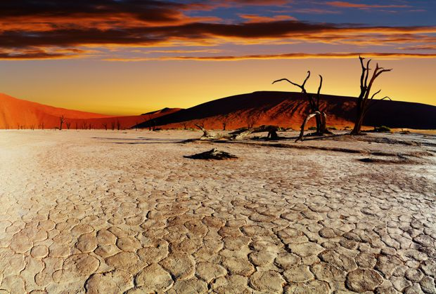

- NAMIB DESERT– Namibia (West of Kalahari)
- Over 1,600 km of coast along SW of Africa, including Angola, Namibia and South Africa, 50 to 160 km wide inland to the Great Escarpment (edge of desert)
- 81,000 square kilometers
- Characterised by some of the largest sand dunes in the world
- One of the oldest deserts in the world

CLIMATE:
- Max Diurnal Range = 9°C (Jun/Jul) (larger inland)
- Annual Mean Range = 5°C
- Mean Max Temp = 22°C (Dec-March)
- Mean Min Temp= 18°C (August) i.e. some seasonal variation as near Tropic of Capricorn and not on Equator.
- Annual Rainfall – 35mm/yr
- COLD OCEAN CURRENT = Benguela Current: a) makes desert cooler than Sahara desert b) creates fog
- Region experiences very little rain but air is often near saturation point = fog
- Fog essential for life. As wind blows east across the cold ocean current it cools the air and water vapour condenses to form fog. The cool air is trapped by the warmer air above it (temperature inversion) resulting in a fog bank forming. Can be up to 20 km wide and forms along the coastal desert.
- Desert is next to the sea = smaller annual range in temp. than Sahara due to the warming effect in winter and cooling effect in summer
- More rain falls inland over the Great Escarpment but water in these streams flowing west into the desert evaporates before it can reach far
- Rain is very rare (only falls on 16 days a year) It can only fall over the Namib Desert when warm, moist air is blown onto the eastern side of the African subcontinent by southeast trade winds. It is highly seasonal.

PLANTS AND ANIMALS:

Animals
Spotted hyena (central and eastern regions), travelling in small groups & feed on gemsbok, mountain zebra
Black-backed jackals often scout beaches for marine carrion (Cape fur seal pups and breeding birds)

Brown hyena
Mountain zebra, chacma baboons, kudu, klipspringer, Cape fox, gerbils, steenbok and a healthy population of leopard are also resident.
Reptiles such as lizards (shovel-snouts, protective eyelids and tubular nostrils allow other lizards to live below the surface) and geckos, the sand snake and the side-winding adder
Scorpions, spiders, fishmoths and beetles that have adapted over centuries to survive in the dune dynamics of the desert.
Insects use a swimming motion to travel through the sand beneath the surface, others dig burrows

Plants
The southern Namib is home to over 600 species of plants, the central Namib 400 species and some 1,000 species in the northern Namib.

Examples:

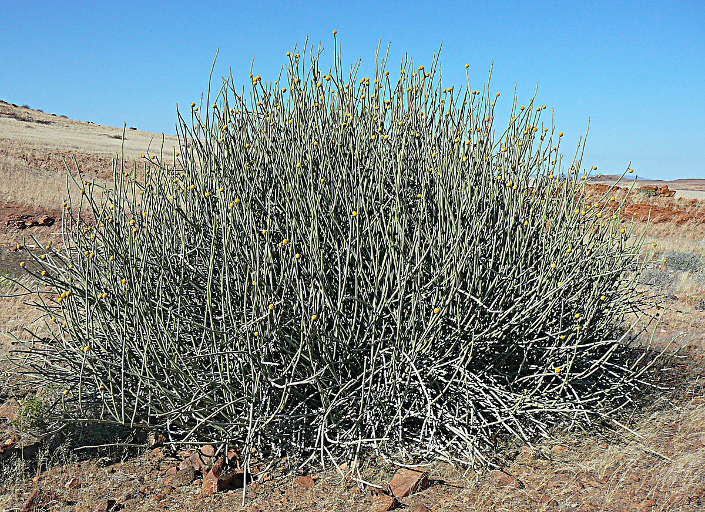 | 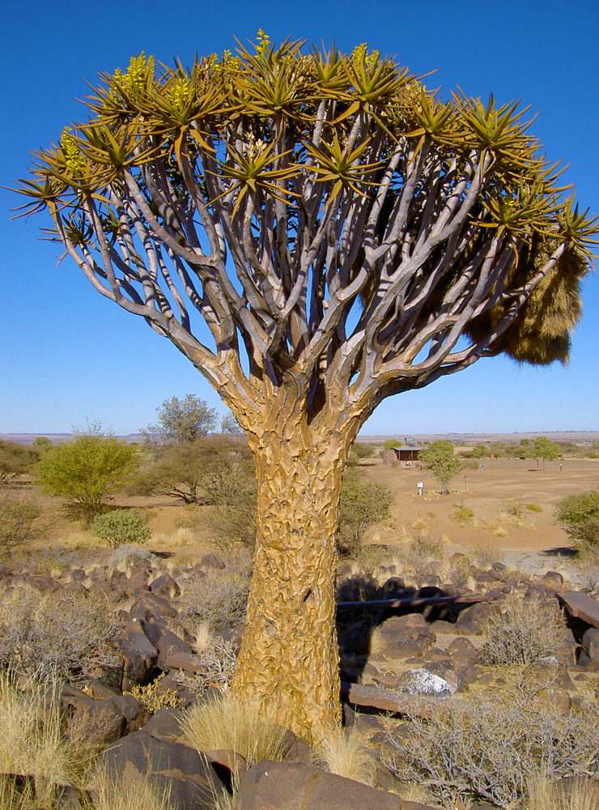 | 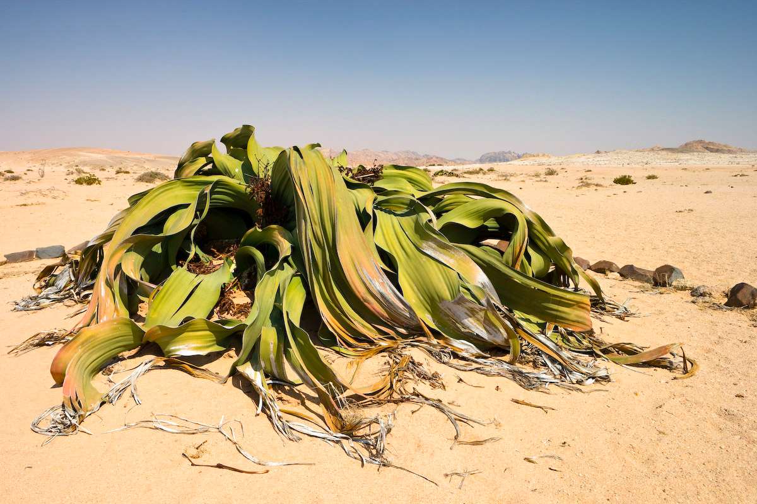
Pencil bush | Quiver Tree | Welwitischia plant
Grows to 2.5 m  A succulent (stores water in its leaves)  Highly toxic to a number of predators. | Grow to 9m and 2-300 years old  Fibrous core to trunk allows water absorption  Long spiked leaves to reduce surface area and water loss  Leaves produce a white powder which acts as a sunscreen | produces only two leaves over a lifespan of over 1,000 years. These leaves cover and protect soil underneath and help retain moisture. These leaves often split into many segments as a result of wind. 1.4 cm thick leaves mean they are undisturbed by high winds and prevent soil erosion. Plant stomata open in fog to absorb moisture and close in sunshine to reduce heat loss (opposite of what you would expect)

Land use

ECONOMIC ACTIVITY | IMPACT
Diamond mining: a big industry historically. diamonds are found in alluvial gravel beds and require huge amounts of sand to be removed to find them and dumped elsewhere | Removing sand damages the roots of the already very fragile vegetation  Dumping sand elsewhere suffocates the habitat
Nomadic herding: donkeys and goats are put out to graze in herds in the eastern regions where rainfall is high enough for some vegetation ground cover. | Overgrazing as lead to land degradation. Soil is devegatted and exposed to wind and water erosion and soil are blown/ washed away
Adventure Tourism: Off-road driving, sand-boarding, go-carting and illegal poaching | Big game animals such as zebras are being wiped out. Desert vegetation is being eroded by vehicles leading to soil erosion
FARMING: commercial and subsistence, pastoral | -Desertification:52% of the land used for agriculture is moderately or severely affected by soil degradation.  -Food shortage due to drought. The rain is neither predictable nor reliable. In 2013, 500,000 people were affected by drought in Namibia

RESPONSES:

- The coastal desert was names a World Heritage Site in 2012: “The Namib Sand Sea”
- Much of the rest of the desert has been declared part of one national park or another to protect the land and prevent diamond mining
- the Namibian Programme to Combat Desertification (Napcod) has been promoting awareness of the risk of desertification among rural commercial and subsistence farmers
- Napcod has also undertaken a major survey of desertification in the country to assess the scale of damage
- Forum for Integrated Resource Management (FIRM) for Namibian farmers to educate on sustainable farming

http://www.namibian.org/travel/namibia/namib-naukluft.htm
https://www.beautifulworld.com/africa/namibia/namib-desert/
https://www.britannica.com/place/Namib:
http://www.informante.web.na/namibia-fights-desertification.14994
https://www.wri.org/sites/default/files/uploads/wrr_case_study_local_level_decision_making_namibia_.pdf

……………………………………………………………………………………………………………………………………

3.1 Development

3.1 A transnational corporation and its global link



CASE STUDY OF A Transnational Corporation (TNC): NIKE

INPUTS: cheap labour (1 million workers in 2013), capital investment ($14.35 billion in 2016), materials e.g. cotton, rubber etc, land, 765 factories, flat land with access to transport routes and labour market, machinery
PROCESSES: sewing, moulding, cutting, storing, transporting, marketing, R&D,
OUTPUTS: sports and leisure clothing, footwear etc. profit (net income of $4.24 billion in 2017) waste

- Established in 1972. First market = USA
- 1980s, opened regional HQ in Japan to access Asian market
- Produces sports and leisure clothing
- HQ is in Beaverton, Oregon (USA) – 5500 people. This is now its main R&D centre
- 2013 Nike had 765 factories in 43 countries, over 1 million workers
- Has grown through its own brand and by absorbing other brands
- Most factories & workers now in SE Asia due to cheap labour, government incentives, cheap local raw materials, big Asian market with free trade and little transport between countries
- Second biggest market is now China (206 factories) due to abundant cheap labour

PROBLEMS:
- Problem: one child policy has reduced labour availability and making it harder and more expensive to recruit workers (Nike salary in China is $500 but in Vietnam it is $250 so Nike is moving to cheaper LEDCs
- Nike has been accused of paying too low wages. In 2010, 20,000 workers in Vietnam went on strike demanding higher pay
- In 2007, Nike decided to relocate from Indonesia which lead to demonstrations as many other industries depended on the factory workers as a market
- Criticised for poor working conditions and for high greenhouse emissions

Solutions:
- Nike set up 1992 Code of Conduct for all factories to improve working conditions and create a fairer rate of pay/ working hours
- More monitoring of employee skills & development from 2001 and set environmental targets
- From 2012 inspections into greenhouse emissions

FOOD PRODUCTION TOPIC

3.2 Food production

3.2 A farm or agricultural system

Food production case study: ROCKELLS FARM, ESSEX
Large scale commercial farming (inputs, processes and outputs)

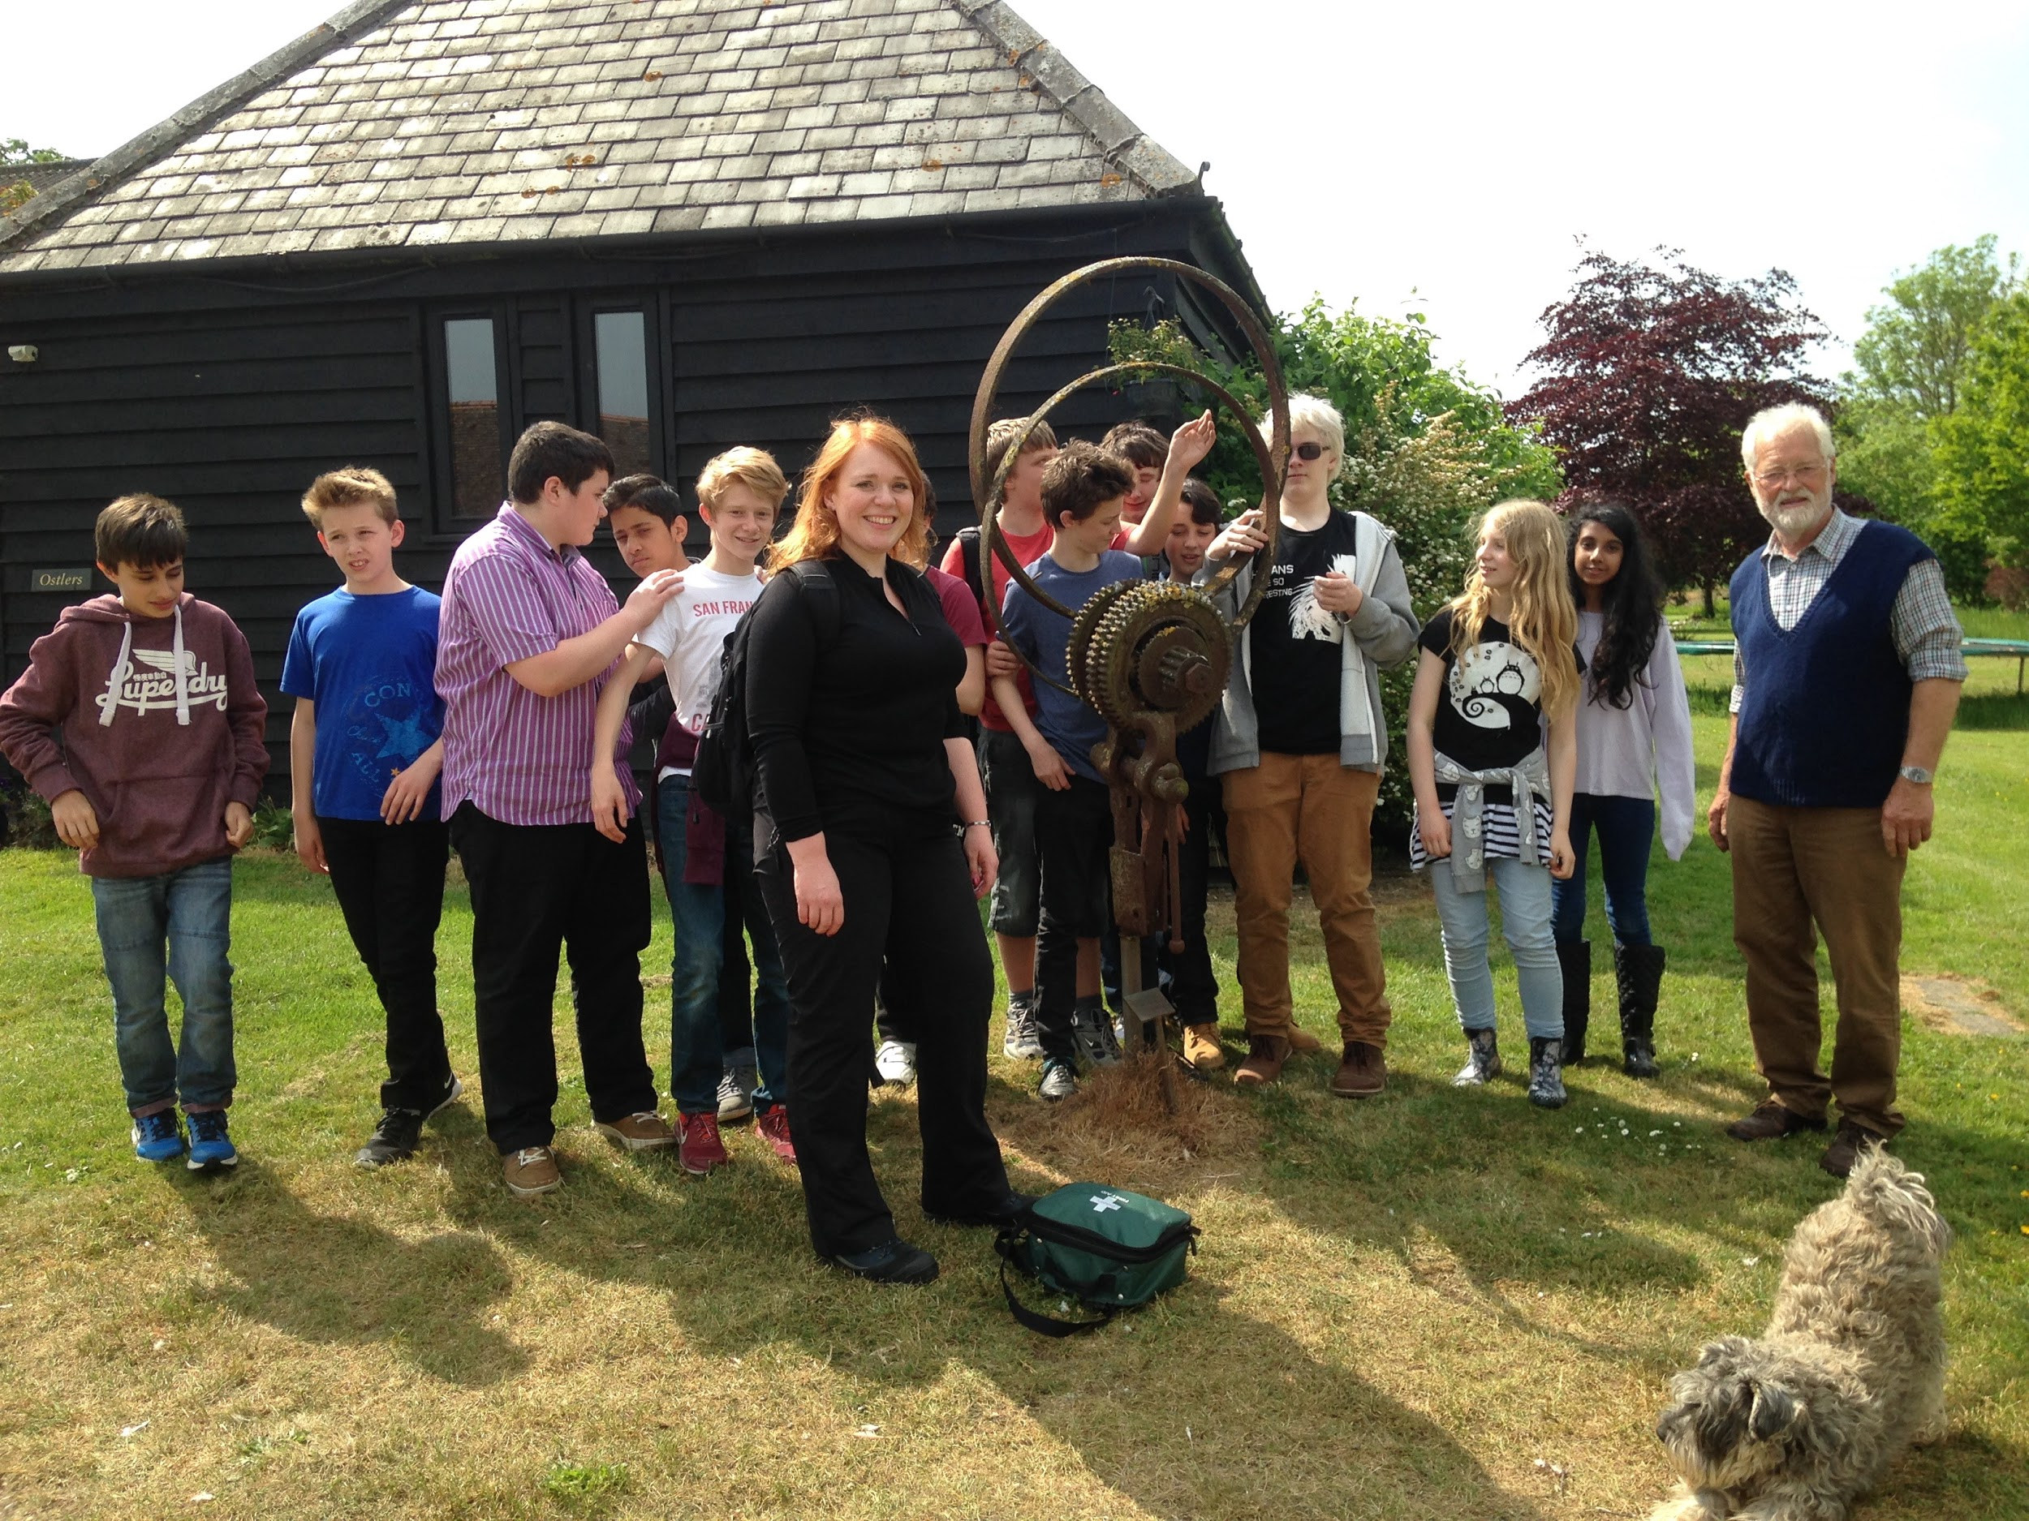
- Rockells Farm, Elmdon, Essex, UK
- Commercial Mixed – 20,000 free range hens, producing 20,000 eggs each day plus grow canary seed
- Turnover is £800,000 per year

Inputs:
- 500 acres of land, gentle relief,
- Chalk/ clay mix (geology), well drained.
- Mild, wet climate. Ave summer temp 17 degrees; 3.5 degrees in Winter. Ave annual rain 650mm.
- Prevailing wind = South westerly. Brings rain
- Use of fertilizers & pesticides. Add nitrates to soil.
- Heavily mechanised e.g. have their own combine harvester, seed drill, tractors. Diesel costs £8000 pa.
- labour: 2 full time, 1-part time employee.
- Diversified their business– holiday cottages, carp fishing lake
- Have 5 solar panels for renewable energy
- Close to M11 and A505 to transport eggs and canary seed
- Machines: 3 tractors, 3 seed drill trailer/ attachments, 3 plough trailers/ attachments, 1 combine harvester/ sprayer
- 6 barns

- 3 grain storage units
- 2 chicken sheds
- chicken wire and fencing
- egg sorting machine
- 20, 000 hens

Processes
- ploughing, seed drilling (use tractor with attached drill or ploughs
- watering, spraying (fertilizer and pesticides), harvesting (combine harvester)
- storage
- transporting canary seed
- feeding hens
- collecting and sorting eggs
- slaughter hens after 1 year
- cleaning out chicken sheds
- adding nitrates to soil

Outputs
- £800,000 turnover
- 20,000 eggs
- 5 tons of canary seed
- waste - chicken excrement

3.2 A country or region suffering from food shortage

Case study: Food shortage in Swaziland

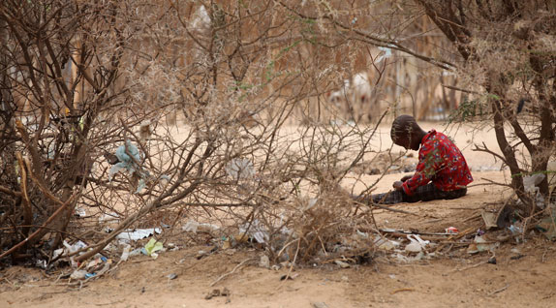

- In 2012 31% of under-fives in Swaziland were suffering from malnutrition.
- Malnutrition in Swaziland is responsible for 8 percent of child mortality.
- Because of an unorganized health system, 69 percent of child malnutrition cases go untreated
- In Swaziland, about 31% of the under-five children are stunted in growth, 6% are underweight and 2% are wasted (2017)
- 26% prevalence of HIV/AIDS (2017)
- The Cost of Hunger in Africa (COHA) survey found that the effects of malnutrition in Swaziland have stunted about 40% of adults. Because the effects of malnutrition can be seen throughout the lifetime of a Swazi, this creates a domino effect in the country.
- 2015/16 El Niño-induced drought in Swaziland indicates the total lost revenue due to the drought in 2016 as US$296 million (E3.8 billion).

Just over three percent of Swaziland’s gross domestic product (GDP) was lost due to child undernutrition in 2009
- With a population of 1.1 million people, 52 percent of whom are under the age of 20,
- Life expectancy is 49 years
- Swaziland ranks 148 out of 188 in the 2016 Human Development Index. Despite its status as a lower middle-income country, 63 percent of Swazis live below the national poverty line.

SEPTEMBER 2017:
- 350,000 people are affected by the prolonged drought predominantly in Shiselweni and Lubombo regions.
- 308,059 people remain food insecure,
- 1,410 children are affected by severe acute malnutrition (SAM) and 7,050 by moderate acute malnutrition (MAM).

Problems
- 2015/16 El Niño-induced drought in Swaziland
- World Food Programme declared Swaziland as a Level 3 emergency (highest level) in 2016
- No rain/ erratic rain when it is expected/ needed in the growing season
- 2 failed harvests in succession (2016)
- Swaziland still not producing enough corn to feed its population
- 63% of Swazis live below the poverty line and have no money to invest in better methods or irrigation. high prices of food and agricultural inputs – such as seeds and fertilizers
- Because HIV is so severe (26% prevalence of HIV/AIDS (2017), many children are orphans (45 percent of children are orphaned or vulnerable)
- About 77 percent of Swazis rely on subsistence farming for their livelihoods.
- High dependence on rain-fed maize production
- high rates of HIV and AIDS among wage earners
- Animal diseases have also weakened herds.
- In november and december of 2000 there was an outbreak of foot and mouth disease
- Soil erosion which makes the land unusable

Solutions
- Government investment into dams and canals to help extend irrigation in the middle and low velds.
- Subsidised farming inputs like seeds and fertilizer would help overcome the lack of capital. Especially for farmers of smaller areas.
- There have also been programs set up for education and training for farmers. An example would be a residential training course at the veterinarian and farmer training center at Mpisi. The organisation behind this has established units to teach farmers about fattening of cattle , dairy production, and also pig, broiler and egg production.
- The UNICEF fund The Power of Nutrition, which hopes to raise $1 billion to tackle children’s nutrition, Swaziland would be able to receive the funding essential for the nutritional overhaul & includes trying to break the cycle of undernourished girls, who become undernourished mothers and give birth to undernourished babies.
- World Food Programme has projects feeding over 55,000 vulnerable children and focuses on nutrition for HIV patients

https://borgenproject.org/malnutrition-in-swaziland/
https://www.ajol.info/index.php/ajfand/article/view/75610
https://reliefweb.int/report/swaziland/unicef-swaziland-humanitarian-situation-report-4-september-2017
http://www1.wfp.org/countries/swaziland

INDUSTRY TOPIC

3.3 Industry

3.3.An industrial zone or factory

Case study of an Industrial Zone: the Cambridge Science Park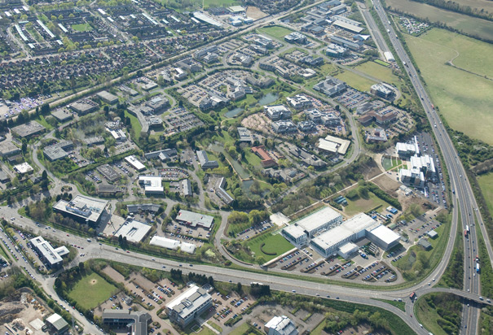

The Cambridge Science Park is a science park (the very first of its kind in the UK) located in Milton, Northern Cambridge. It specialises in inviting new and developing quaternary companies to expand and thrive through the safety, solitude and provisions of the park. It was founded in 1970 with the idea to research and develop with high-tech equipment.

In the 1990s, the market for hi-tech companies in Cambridge grew and as a result lead to the expansion of the park with 1,200 new companies 35,000 new jobs. Incubators were established around Cambridge and venture capital fund in the UK increased dramatically.
At the end of the 1990s, the life science sector started to grow and become the dominant sector in the park. There are now 106 companies in the Science Park of varying sizes.

One such company is One Zero One, an R&D company that went from a startup in Cambridge Science Park to a £17 million company with a large 80,000 sq ft office as their headquarters. They have also attracted the attention of quaternary juggernauts: Philips and Citrix.

Factors influencing location
Cheap land (donated by Trinity College, outside city)
Large space (152 acres) but flat and well drained
Attractive countryside all around to attract and inspire workers
Proximity to Cambridge city (2 miles south): theatres, restaurants, 2 shopping centres, schools, cinemas, amenities etc. to keep workers happy

Cambridge University: very highly skilled labour but also other specialist colleges
Good housing: new stock being built e.g. Willingham
Access: Cambridge North opened 2017 45 minutes to London. Stansted, Cambridge and Luton airports. M11, A14. Cycle paths, guided bus. = access to European and global markets
Agglomeration: Science park, Genome Campus, Biomedical campus at Addenbrookes

INPUTS | PROCESSES | OUTPUTS
Physical  152 acres of brownfield (flat vegetated) land surrounded by farmland (greenfield)  Very gentle relief  Good drainage  Mild climate  Human  Highly skilled labour: Cambridge University, London universities nearby  Market:SE England, high income. 13% higher income than rest of UK  5 fibre optic broadband services  Nursery and creche  Restaurant  20 acres of landscaped grounds  Health and fitness centre  Cambridge North Station  Guided bus  Cycle paths  One Zero One £17 million new office building  Multiple office buildings & car parks  Energy & water supply  Conference centre  UK venture capital | Businesses: Biotechnology, telecommunications, medicine development, web development  Programming, transporting products, scientific research,wet lab research, manufacture of medicines, web development, analysing data, marketing, communications, meetings, data analysis | Knowledge, information, medicines, new technologies, capital, profit (annual revenue of over £13 billion) waste

TOURISM TOPIC

3.4 Tourism

3.4 An area where tourism is important

CASE STUDY of an area where tourism is important: LANZAROTE, CANARY ISLANDS (Spain)
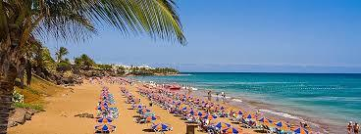

1.8 million Tourists visited in 2012. About 800,000 were British. At peak times the population of the island can increase by half again from 142,000 to 200,000 due to the influx of tourists. There are 407 taxis in Lanzarote

Why visit Lanzarote?

Weather:
- Often less than 30 days of rainfall a year.
- Often no rainfall in June, July and August
- Temperatures tend to always be above 20 deg c
- Summer temperatures around 28 deg c

Landscape Attractions (naturally occurring)
- Volcanoes for geography teachers to visit. E.g. the Timanfaya National Park a 50km² volcanic landscape.
- Geothermal phenomena.
- Beaches with crystal clear waters, e.g. the main beach of Playa Grande, these have some of the highest cleanliness ratings in the world.
- The volcanic caves of Los Verdes
- El Golfo, a volcanic crater filled with water and green due to algae growth.
- Ajache Mountains, lots of trekking routes and mountain huts for tourist use.

Human Attractions (human made)
- Lanzarote Aquarium
- Costa Teguise Golf Course
- Windsurfing
- Theme Park (Rancho Texas Lanzarote park)

Why did tourism grow?
- Safe, low crime rates, resorts with no right of way for locals to access, which made them isolated tourist havens.
- 1billion investment in infrastructure between 1975 and 1985 including 5 purpose built resort complexes and tourist centres so not to disrupt local life.
- A good supply of clean water, through desalination plants (expensive at around 7 million euros just to build) currently 3 on lanzarote
- Good road networks invested in by Spain, LZ1, LZ2 & LZ3 are the main highways taking traffic from East to West.
- From the 1980’s flights were more accessible and the airport was able to cope with larger planes. Today a ticket can be as cheap as £89/return from Manchester airport.

Benefits to Lanzarote?
Economic: 1 in 10 employed directly or indirectly by tourism.
Directly (e.g. serving in a hotel restaurant) Indirectly (e.g. providing mechanical support for air conditioning units in hotels)
Average wage is 18,500 Euro, compared to 2,089 Euro in neighbouring Morocco.

Social:
Tourists appreciate historical local activities of the island which has helped preserve industries such as sea salt production, sugar production, small scale wine production and goat farming for cheese production.
Hotels often provide (in fact 65% of hotels) childcare facilities for working mothers and have strong links with local schools to help improve educational standards.
Places feel lively with tourists which is reducing the number of young people leaving the island as there is a good social life and plentiful employment.
Locals are learning English through interaction with tourists, enhancing their level of education.
Environmental: Protection of natural resources and creation of national parks, e.g. Timanfaya National Park and the Biosphere status (1 of only 564 sites around the world).

Problems for Lanzarote?
Economic: In some regions, locals suffer inflated prices for every day goods as local shops cash in on how to make money from tourists! A loaf of bread in peak tourist season rises 60% in price.
Locals are now reliant on tourism, to the extent that tourism is reckoned to be responsible for nearly 80% of island income. This over-reliance could be dangerous if their tourism industry was to collapse.
Social: Locals feel that they have lost traditional values, like family time at weekends as many are working in hotels or to support the tourist industry.
An increase in divorces by 22% since 1980, partially linked to the stress of antisocial working hours.
Overcrowding on streets in the high season and traffic congestion (journeys take 20-40% longer in peak tourist season).
Overdevelopment threatens Lanzarote’s Biosphere status.
Growing resentment between locals and governments who feel that politicians take the benefit of increased income etc. and it doesn’t filter down to the locals or infrastructure.
Many are concerned that planning applications are aimed at benefiting tourists and locals are not properly considered.

Environmental:
Tourist firms over exploit natural resources, deforestation has led to almost 90% of the islands trees being removed, most linked to tourist activity.
Litter
Pollution of water
Footpath erosion
Disruption of habitat and wildlife with hotel development and construction and nightlife

Overcoming the problems:
Politicians are starting to consult locals on new building projects.
Tourism Tax to reduce the annual visitors to the island and help limit further growth of tourism. Its not currently in place but is expected in the next 5 years. Possibly as an ‘airport tax’ on departure or arrival.
More national and local nature reserves and legislation to reduce excessive visits

ENERGY TOPIC

3.5 Energy

3.5 Energy supply in a country or area

Case Study of Energy Supply in a country: Iceland

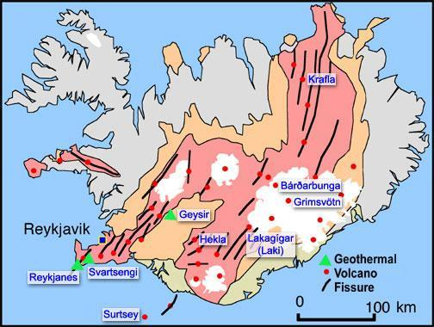

Key Facts
99% of Iceland energy is Renewable

30% Geothermal
60% Hydroelectric
9% Other renewables
Orkuveita Reykjavík, Reykjavík’s hot water utility, is the largest geothermal heating utility in the world
Only 11% of Iceland’s geothermal potential is being utilised with plans to expand and extend the network.

FOCUS: GEOTHERMAL ENERGY:

How geothermal energy is produced & developed by governments
Temperatures in the Earth’s core are very high, >5000°C. Deep underground, rocks & water absorb heat from the magma. Water is pumped down an “injection well”, filters through cracks in the rocks in the hot region & comes up “recovery well” under pressure. It turns into steam upon reaching the surface, which may be used to drive generators to produce electricity, or passed through a heat exchanger to heat water to warm houses.
In 1940s, the National Energy Authority was started by the government in order to increase the knowledge of geothermal resources and the utilization of geothermal power in Iceland. This agency has been very successful and has made it economically viable to use geothermal energy as a source for heating in many different areas throughout the country. The government no longer has to lead research in this field as geothermal power has been so successful & has been taken over by the geothermal industries.
Iceland government also thinks there are more untapped sources of geothermal energy; after tapping them to their full extent, it is estimated that Iceland would get another 50 TWh of energy per year – all renewable.

Location factors considered
- Economy of the area – Blue Lagoon, a tourist bathing resort/ geothermal spa which is one of the most visited attractions in Iceland. Money earned from tourism thus makes the area richer & more economically sustainable than it previously was.
- Needs of people – Nesjavellir Geothermal power station was built to satisfy the hot water demands of people in settlements nearby. All geothermal power stations were built to help
- Near a heat source from the Earth – can be near volcanoes/ reservoir, where injection wells built can first inject cool water into hot basement rock near magma, and the water is heated up and then extracted out again by doublet wells

Benefits
- Low operational & maintenance costs, thus the power plant company can make more profits from providing electricity from geothermal power.
- Renewable source of energy, can replace coal, oil and natural gas which are running out fast. Geothermal energy is environmentally friendly compared to fossil fuel plants, as they only produce a small amount of carbon monoxide.
- Can be a tourist attraction, e.g. Bjarnarflag Geothermal Station has many tourist services nearby. Svartsengi Power Station supports Blue Lagoon, a geothermal hot spring. This could bring in more money for the region, making it more economically sustainable as tourists also go mountain climbing & skiing nearby.

Costs
- Require high investments in machinery. Hellisheidi Power Station decided last October that a number of turbines will be added, along with 90MW – these amounts to $197 million. Construction of a plant & well drilling costs ~ €2-5 million per generated MW of electricity.
- If not done with adequate care enhanced geothermal systems can trigger earthquakes, thus severely affecting land stability & putting nearby areas at risk – potential threat to settlements.
- Before access to potentially huge amounts of energy, the success rate for discovering geothermal resources in new untapped areas is ~20%. In areas near wells already producing, it is 80%.

WATER TOPIC

3.6 Water

3.6 Water supply in a country or area

ENVIRONMENTAL RISKS OF ECONOMIC DEVELOPMENT TOPIC

3.7 Environmental Risks of Economic Activity

3.7 An area where economic development is taking place causing the environment to be at risk

Case study: Environmental Activity Impact on the Environment: Palm Oil Production in Borneo

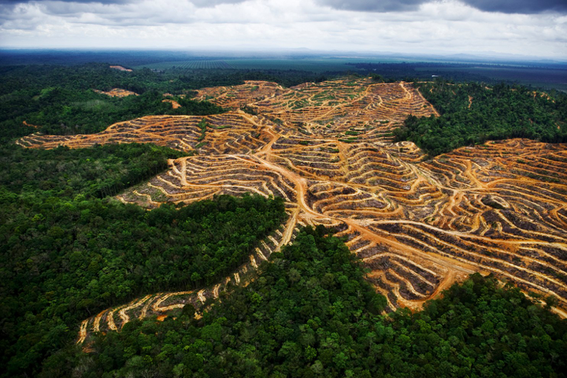

- Palm oil from palm fruit
- 85% of all global palm oil comes from Indonesia & Malaysia
- 8 million acres of Borneo now given over to Palm Oil plantations (size of Switzerland!)
- Production has tripled in last 20 years
- Fast growing trees require warm and wet climate… Borneo is ideal
- Requires many unskilled workers. Indonesia actively encouraging growth of Palm oil production
- As palm oil is the cheapest vegetable oil, the demand for this commodity as a source of food and energy is expected to rise rapidly. The demand for food alone is expected to double in the next decade, and the Indonesian government has responded by setting a target to increase oil palm production from 20 million tonnes in 2009 to 40 million tonnes in 2020
- In order to create plantations, huge areas of forest are cut down and then burned leading to severe land degradation

ENVIRONMENTAL IMPACTS:
- Air pollution & smoke: Forest fires of 2008 lead to a ‘Brown Cloud’ over SE Asia that led to 30% of annual greenhouse gas emissions
- Orangutan population has fallen 50% in 50 years
- When forests are cut down, the soil is left exposed to the rain. In the event of heavy rainfall, the erosion in the upper catchments of all the big river systems has the potential to lead to major damage downstream including flooding and blockages
- When left undisturbed, Borneo’s natural forests are not usually prone to fires. But as forests are opened up by humans, they dry out and are increasingly susceptible to fires, which causes dangerous atmospheric haze and destroys valuable animal habitat and untold species of plants
- If local’s fish source is disrupted, salaries aren’t high enough for workers to afford legal food sources...what happens next is an increase in the illegal bushmeat trade and, in time, a severe threat to vulnerable and endangered species
- Deforestation leads to soil erosion and leaching of nutrients from soil due to heavy rain

SOCIAL IMPACTS:
- Indigenous tribes such as Penan Tribe being left homeless
- Small scale farmers and rubber tappers displaced to make way for palm oil plantations
- Health hazard of smoke and fire
- Palm oil plantations load up the rivers with sediment caused by soil erosion, gradually destroying the waterways with nutrient overload and pesticides. This degrades fish stocks, which undermines the local people’s access to protein. Most people living in the Borneo rainforest get their protein not from the forest itself, but from the rivers flowing through it..

ECONOMIC COSTS
- Poor management of upstream land and vegetation also has well-known adverse implications on hydroelectric facilities, filling up dams with sediment and damaging turbines. The economic costs that then arise can be massive.
- Similar adverse effects can be experienced on a smaller scale by rural communities at the downstream end of small catchments. The cost may not be high to the State or the economy at large, but rural villages may suffer economically and socially.
- Fire and haze produce many adverse effects ranging from impacts on human health (can’t work) short and long-term medical treatment costs, losses in tourism and forfeited timber revenue.

Scale of deforestation in Borneo:
- The region has lost over half of its forests, and a third of these have disappeared in just the last three decades.
- Current deforestation rate of 1.3 million hectares per year
- deforestation is accelerating and more than 8 million hectares were lost between 2000 and 2010, accounting for 12 percent of its 2000 cover
- Borneo TRFs are said to be 130 million years old, the oldest on the planet.

General consequences of deforestation
- Soil erosion: When forest areas are cleared, it results in exposing the soil to the sun, making it very dry and eventually, infertile, due to volatile nutrients such as nitrogen being lost. In addition, when there is rainfall, it washes away the rest of the nutrients (LEACHING), which flow with the rainwater into waterways. Because of this, merely replanting trees may not help in solving the problems caused by deforestation, for by the time the trees mature, the soil will be totally devoid of essential nutrients. Ultimately, cultivation in this land will also become impossible, resulting in the land becoming useless. Large tracts of land will be rendered permanently impoverished due to soil erosion.
- Disruption of the Water Cycle: Trees contribute in a large way in maintaining the water cycle. They draw up water via their roots, which is then released into the atmosphere (evapotranspiration). A large part of the water that circulates in the ecosystem of rainforests, for instance, remains inside the plants. When these trees are cut down it results in the climate getting drier in that area.
- Loss of Biodiversity: The unique biodiversity of various geographical areas is being lost on a scale that is quite unprecedented. Even though tropical rainforests make up just 6 percent of the surface area of the Earth, about 80-90 percent of the entire species of the world exist here. Due to massive deforestation, about 50 to 100 species of animals are being lost each day. The outcome of which is the extinction of animals and plants on a massive scale.
- Flooding and Drought: One of the vital functions of forests is to absorb and store great amounts of water quickly when there are heavy rains. When forests are cut down, this regulation of the flow of water is disrupted, which leads to alternating periods of flood and then drought in the affected area.
- Climate Change: It is well known that enhanced global warming is being caused largely due to emissions of greenhouse gases like carbon dioxide into the atmosphere. However, what is not known quite as well appreciated is that deforestation has a direction association with carbon dioxide emissions into the atmosphere. Trees act as a major storage deposit for carbon, since they absorb carbon dioxide from the atmosphere, which is then used to produce carbohydrates, fats, and proteins that make up trees. When deforestation occurs, many of the trees are burnt or they are allowed to rot, which results in releasing the carbon that is stored in them as carbon dioxide. This, in turn, leads to greater concentrations of carbon dioxide in the atmosphere. So deforestation has a double whammy - releases stored CO2 and then is unable to absorb any more.
- Disease: A recent pieces of research has found that "A 4 percent change in forest cover was associated with a 48 percent increase in malaria incidence in these 54 health districts of the Amazon," It would seem that "The deforested landscape, with more open spaces and partially sunlit pools of water, appears to provide ideal habitat for this mosquito," Olson says of Anopheles darlingi, the primary carrier of malaria in the Amazon. In deforested areas Anopheles darlingi displaces other less-malaria prone mosquitoes that favour forest landscapes

